Docman 10 RMS Appointments/Booking User Guide

Docman 10 RMS Appointments/Booking User Guide
Version: 0.4
01 November 2017

Docman RMS/ EDM Appointments Booking Handout

Contents
Accessing Docman 3
To log in to Docman 3
To Log Out of Docman 4
Docman Inbox’s and Reviewing Tasks in Docman 5
Docman Tasks 5
Inbox and Views 6
Selecting and Reviewing a Task 7
Show Activity 7
Add a task 8
Quick Steps 10
Using a favourite quickstep 10
Searching for a quickstep 11
Forward and CC 13
Annotate 15
Pause, Stop and Decline 16
Recent Tasks 17
View Documents or History of a Document in Docman 20
View a Patients Documents and Recent Documents 20
Additional Help and Docman Resource Material 23

Accessing Docman

To log in to Docman

- Access the internet
- Access your Docman URl Link
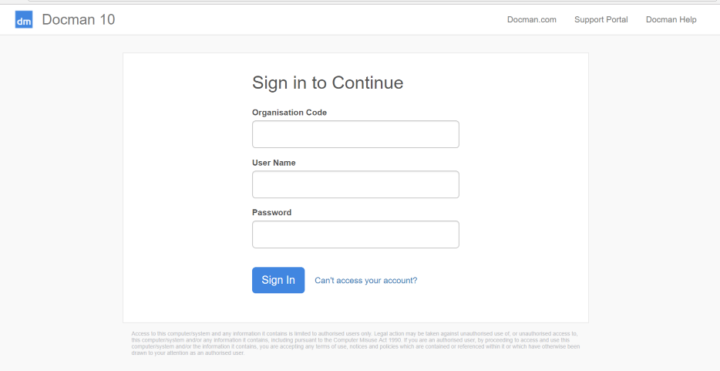
- You will then be promoted to insert an Organisation Code, Username and Password
- Insert your Organisation Code that was sent to you by the System Administrator
- Insert your username that was sent to you by the System Administrator
- Insert the password that was sent to you by the System Administrator
- Click on Sign In

If your organisation uses single sign on navigating to the screen and where single sign on has been used previously will allow the automatic sign in to Docman.

On first login you may be asked to create a new password if a temporary password has been provided
- Enter your new password into both fields and click OK.
The new password must be at least 8 characters and contain upper case, lower case and a number.

To Log Out of Docman

- From the Docman Toolbar, Click User

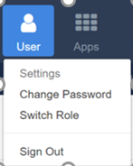
You will then be given 3 options:
- Settings – This will allow you to access back end settings if you have correct admin permissions associated with your role
- Change Password– This will allow you to change your password in the system
- Switch Role – If you have a dual role within the system e.g. scanner and file role and system admin, selecting switch role will allow you to move to full permissions under your other assigned role
- Sign Out – Clicking sign out will log you out of Docman and you will be required to login again to access the system

Docman Inbox’s and Reviewing Tasks in Docman

Docman Tasks

The section covers how to access Tasks that have been received for action and review.

- You can access you Tasks by selecting the Tasks icon on the toolbar

The workflow tile will be Yellow to indicate you have workflows to view and Red if there are any High Priority or overdue workflows to view.

- This will open your Task window
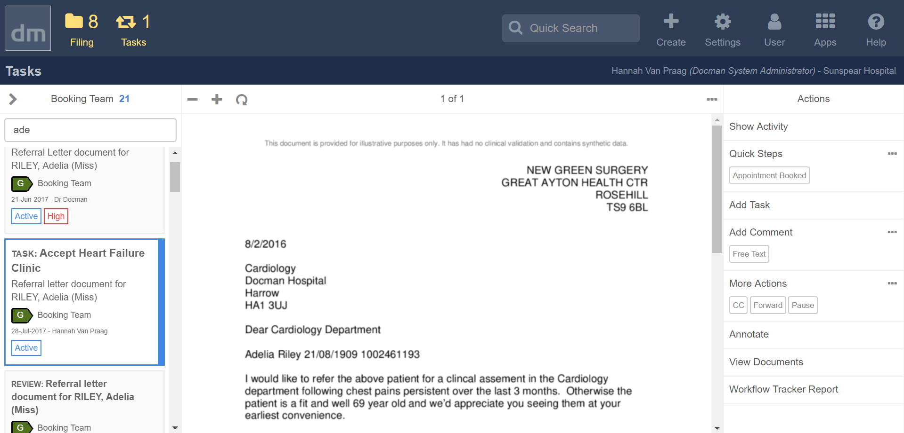
Your inbox is on the left hand side of the screen and can be opened up to allow you to see and filter tasks that you have received

Inbox and Views

The section covers how you access the different inboxes and views of Tasks that have been received post clinical review
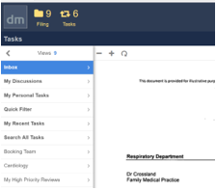
- Inbox – All documents in your inbox
- Your personal tasks
- Your recent tasks
- Search all tasks
- Tasks by groups that you are a member of
- High priority tasks that need review

You will be sent tasks to you as an individual or to the group/s you are a member of
- To view your own tasks select personal tasks
- To view tasks for a group you are a member of select that group – Example you may be a member of Cardiology Booking Team and Respiratory Booking Team therefore will have to views for each group

Selecting and Reviewing a Task
The section covers how to select and review a Task that have been received post clinical review
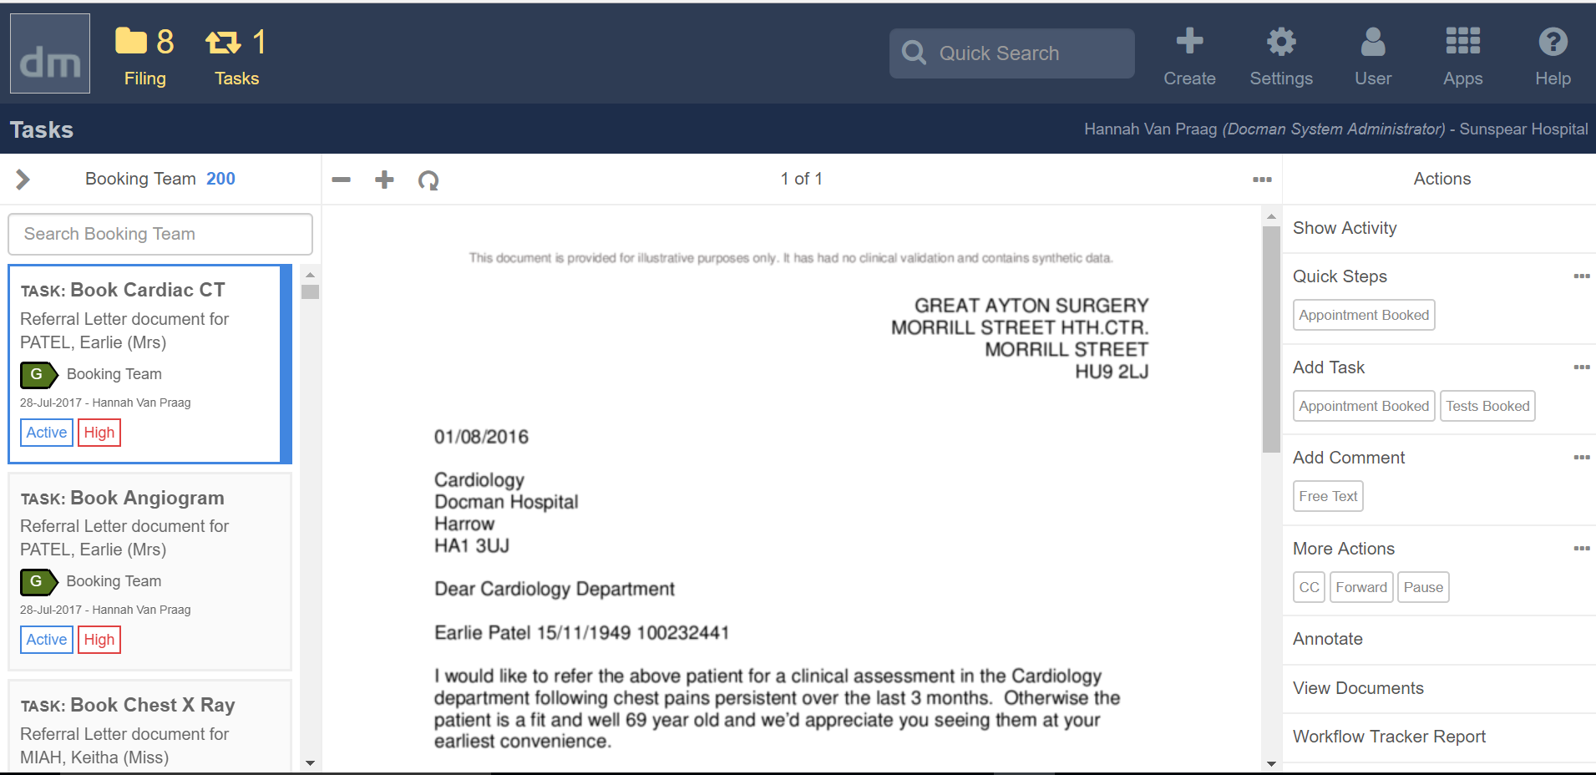

- Select a document in your inbox
- The Clinical Correspondence document will preview in the middle section of the screen
- All Actions that you are able to complete in relation to this task will appear on right hand side

Show Activity
The section covers how to view the history of a Task that you have received and the activity that has been added to the task

- Select a document in your inbox
- Click Show Activity
- The activity that has taken place on this document will be shown on the right hand side of the screen
- To remove the activity click Hide Activity to return to your task review

Here you will be able to see if any tests or additional tasks have been organised. You may need to delay booking appointment until these tests are booked and taken place if required

Add a task
The section covers how to add a task to a document.

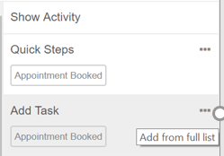
- Select a document in your inbox
- You will see your favourite tasks showing within the Add task section
- Click the required task to add to review or select … to search for required task
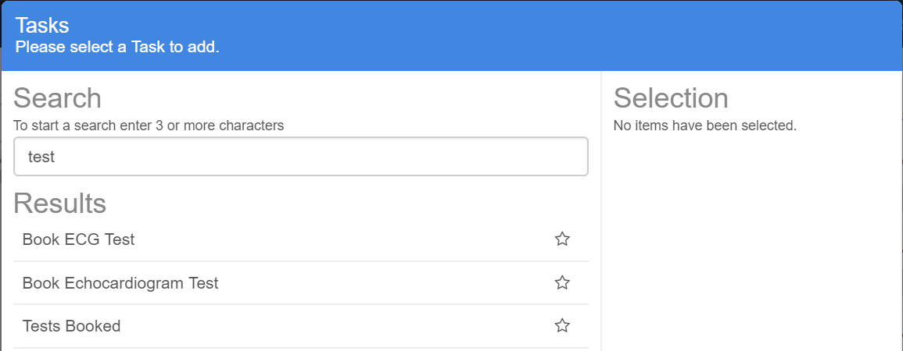
- Insert search criteria and click enter
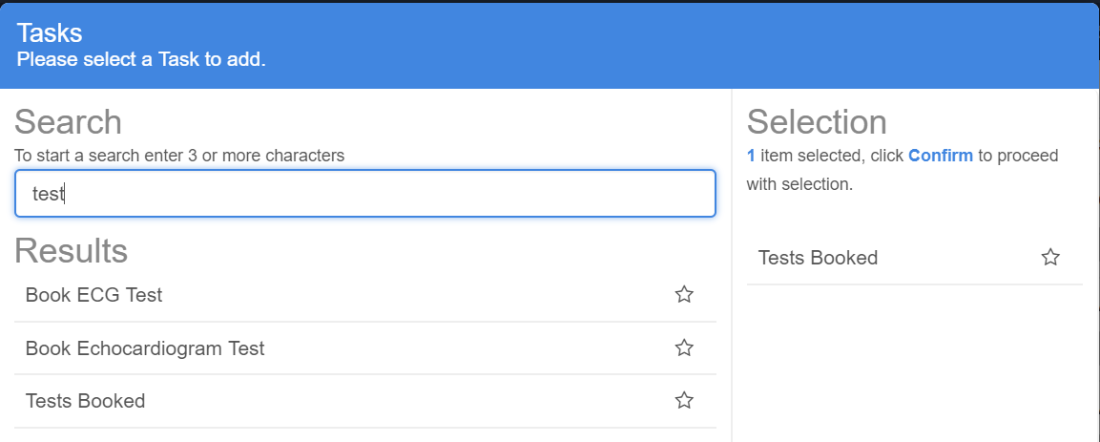
- If you wish to use task one select task to move to selection pane and click confirm
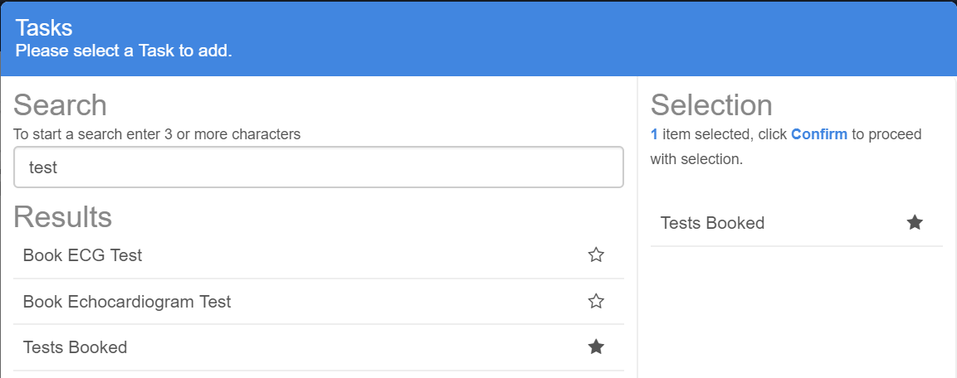
- If you wish to use this task regularly and make a favourite select the star and click confirm
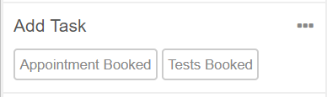

- This will then appear on you main reviewing screen

Add a comment
The section covers how to add a comment to during to a document.

- Select a document in your inbox
- You will see your favourite comments showing within the Add Comment section
- Click the required comment to add to review or select … to search for required Comment
- Insert search criteria and click enter
- If you wish to use comment one select comment to move to selection pane and click confirm
- If you wish to use this comment regularly and make a favourite select the star and click confirm
- This will then appear on you main reviewing screen

Quick Steps
The section covers how to use a quick step to include and outcome of your clinical review of the document. Quicksteps allow multiple tasks, actions, comments to be used in one click.

Using a favourite quickstep

- Select a document in your inbox
- Use an appropriate quick step to complete the clinical review
- You will see your favourite Quick Steps showing within the Quick Steps section
- Click the required Quick Step Example select “Appointment Booked” to add the outcome to the correspondence
- You will then be presented if required to confirm timescales, any bloods or x-rays required if mandatory as part of the quick step
- Once quick step used your screen will refresh and you will be able to triage the next clinical correspondence in your inbox

Searching for a quickstep
- You are able to search for a quickstep if not showing in the Quick step section
- Select … to search for required quickstep
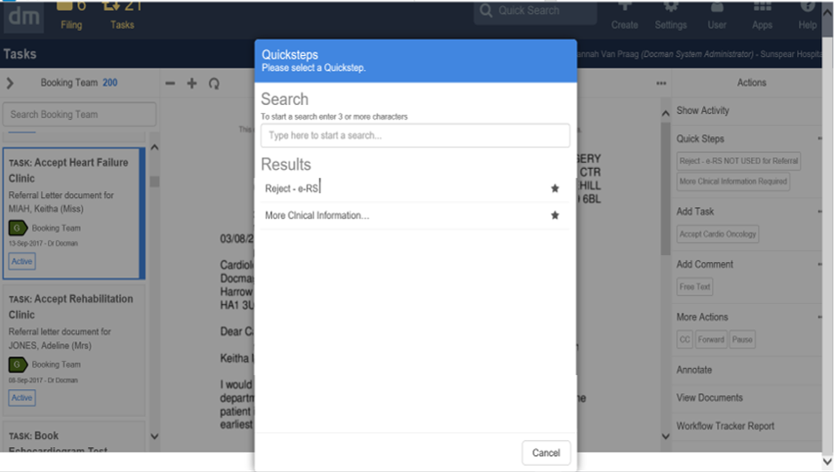

- The quicksteps assigned to you that are able to be used will be shown
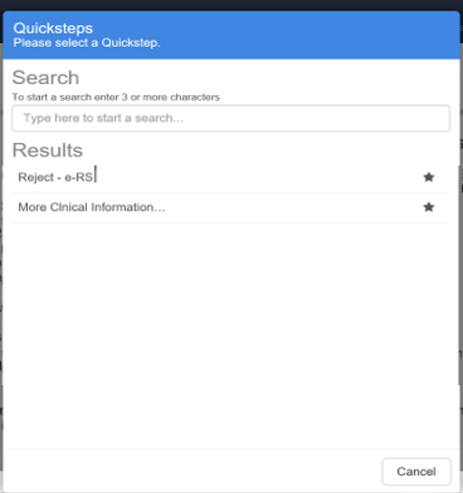
- If you wish to use this quick step regularly and make a favourite select the star and click confirm
- This will then appear on you main reviewing screen

Forward and CC
The section covers how to forward or cc a colleague into a task

- Select a document in your inbox
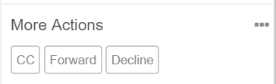
- Select the required forward or cc in the more actions review panel

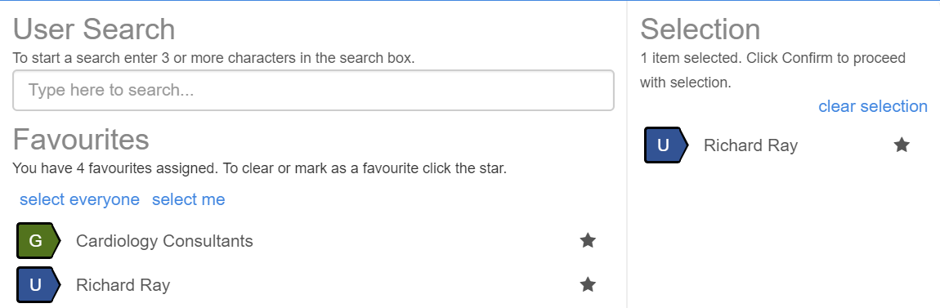

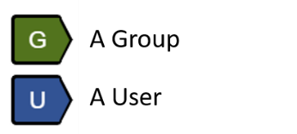

- Within the Forward or CC box it will show you your favourite users and allow you to search for a Docman user to CC or Forward clinical correspondence to
- Click user or group to select required user or group will appear in selection panel
- Click confirm

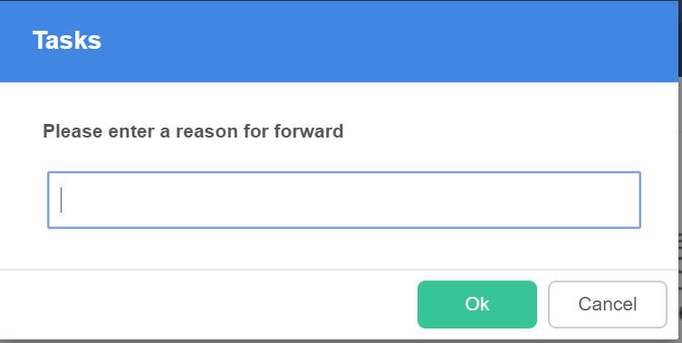

- You will be prompted for reason for forwarding a referral on to another user

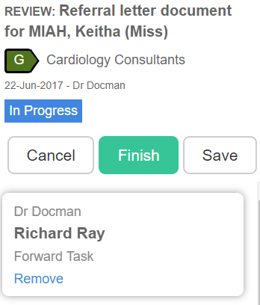

- Click Finish to complete the action will be sent over to other user

Annotate
The section covers how to annotate a Clinical Correspondence that you are reviewing.

- Select Annotate from the action panel on the right hand side

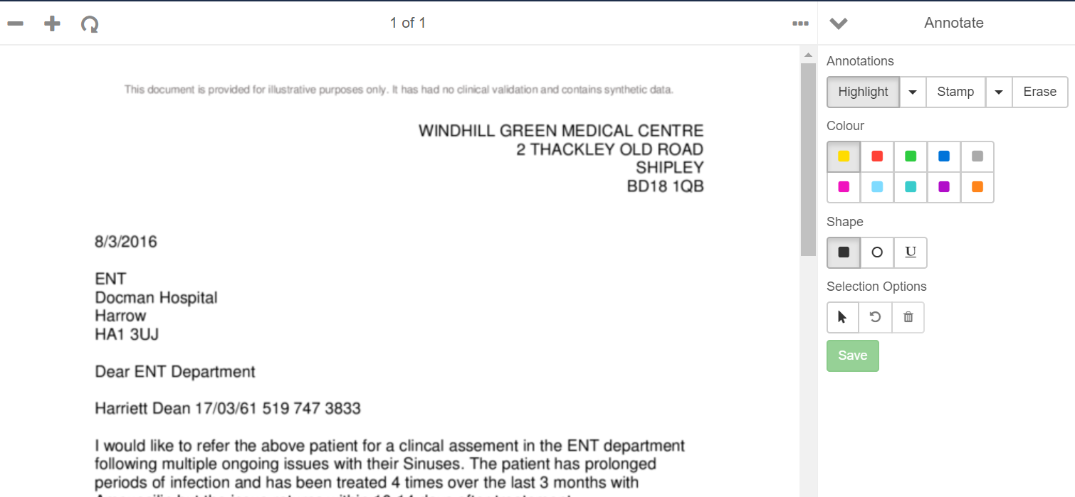
Highlight
- Select highlight and colour required
- Select Shape
- Highlight required text within the document
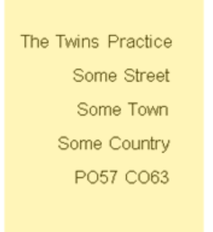
- Once highlighted click save

Stamp
- Click Stamp
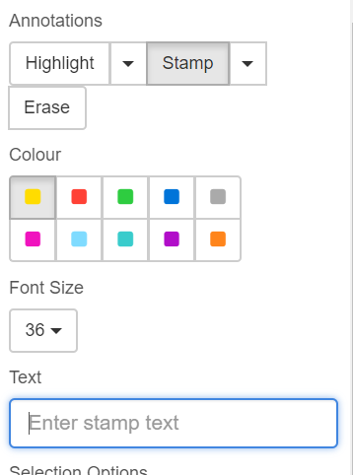
- Choose stamp colour
- Choose Font Size
- Insert stamp text
- Click Save
- Click area of screen to insert stamp

Pause, Stop and Decline
This section covers how to used Pause, Stop and Decline actions within Docman

- Select Pause, stop or decline in more actions panel
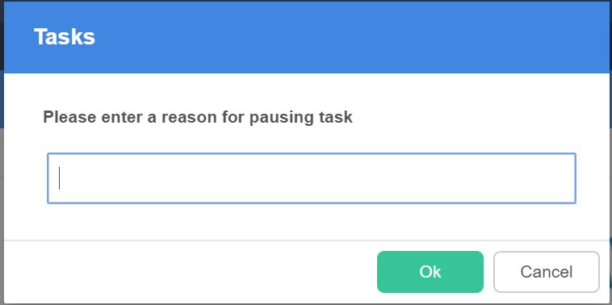
- You are promoted to enter a reason for pausing, stopping or declining a task this will be audited and added to the history of the task

Recent Tasks
The section covers how to access and adjust recent tasks that you have reviewed that you wish to make alterations to.

- Select your inbox views
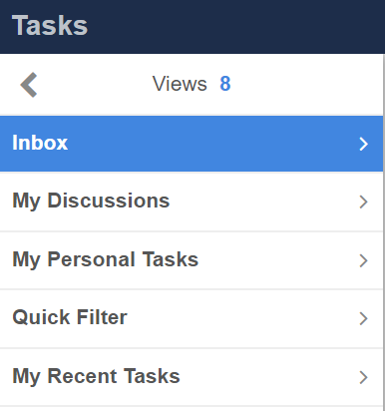
- Select my recent tasks
- This will show you the tasks that you have recently actioned and reviewed
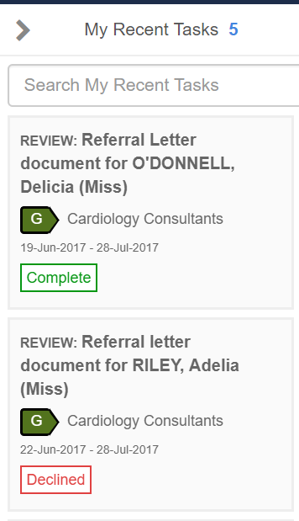
- Select required task
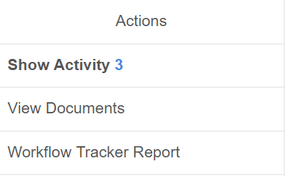
- Select View Documents from the Action Panel

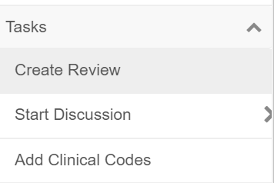
- Select Task drop down and select create review to edit the task select create review
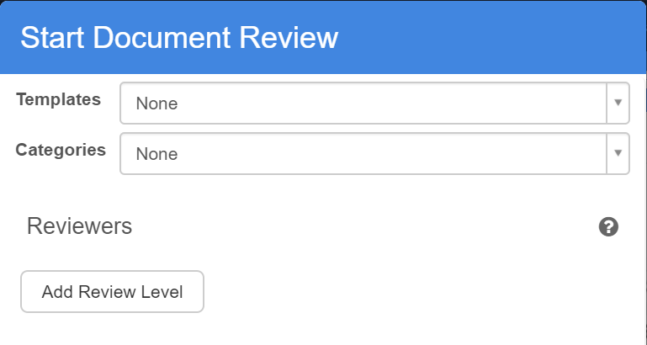
- Select Add Review Level
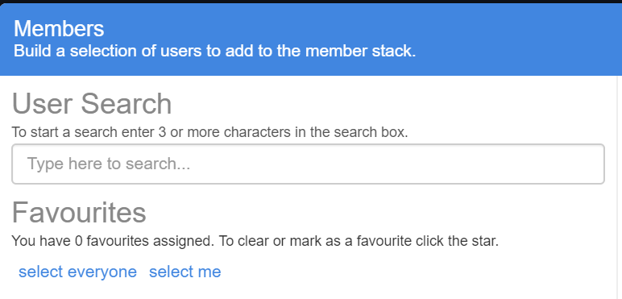
- Select Me
- Click Confirm
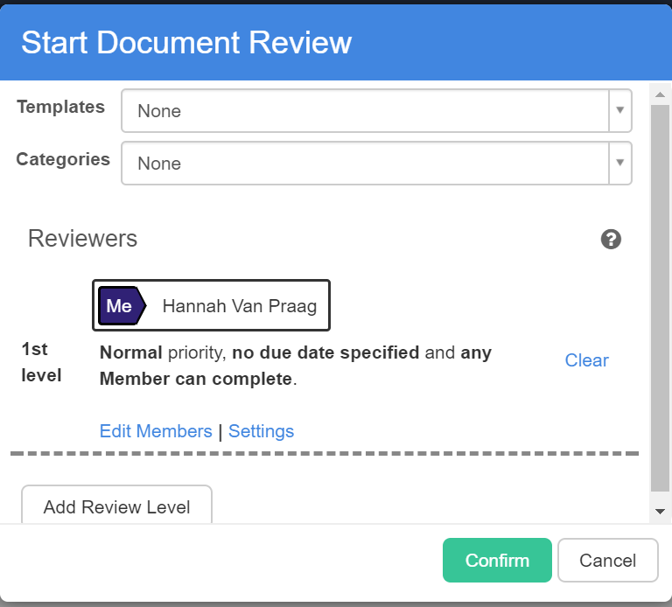
- Click Confirm again to confirm all the details
- Pop up shows review created
- Return to inbox to adjust review and add required information to task

View Documents or History of a Document in Docman

View a Patients Documents and Recent Documents
The section covers how to search for patient documents and how to view recent documents that you have accessed

Search for a specific patient’s document
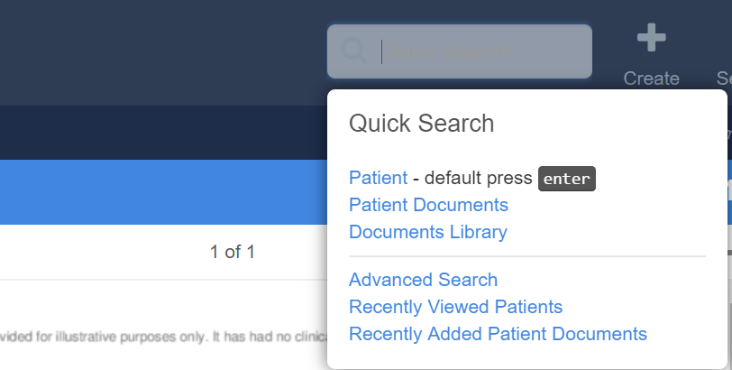
- Select Quick Search from the toolbar
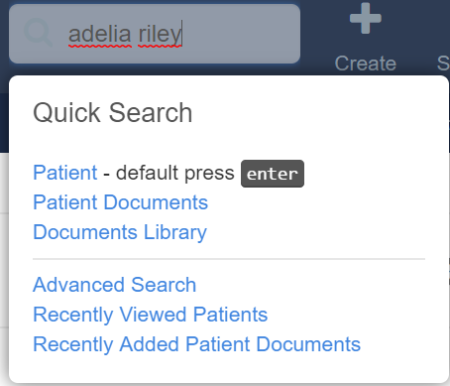
- Insert patients details and click enter
- The patient/s that match the search criteria is then shown
- Double click on correct patient to view all the documents for this patient
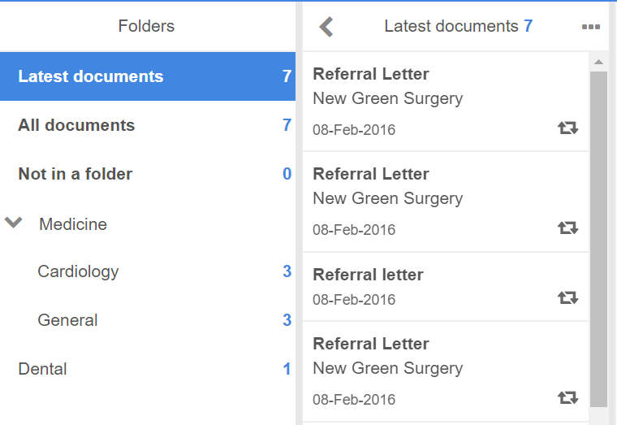

- As well as seen all documents for the patient you are also able to open up the folder structure to see documents for a specific speciality only

View History of Document
The section covers how to view the history of a document

- Search for patient and specific document
- Select the document that you wish to view history
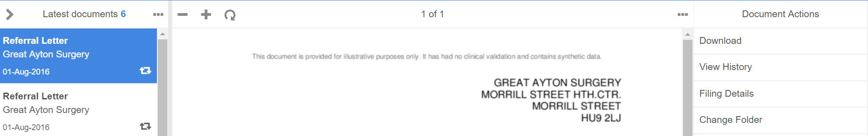

- Select View History from Document Actions panel
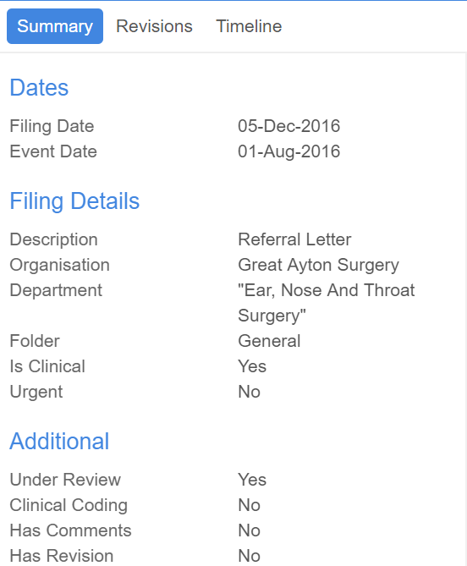

  - Summary – Provides summary of document including date filed, event date, department, priority, under review to help determine if it is still being reviewed, has comments, has revisions

  - Revisions – will notify you and show revisions made to document

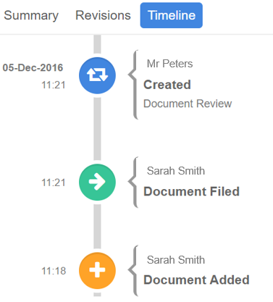
  - Timeline - will show a pictorial timeline of what has taken place with the document since it was added to the system

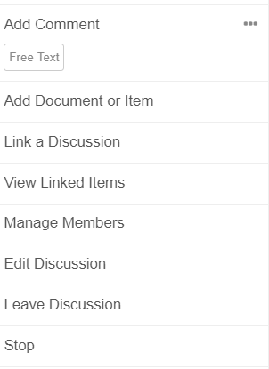

Additional Help and Docman Resource Material
Additional help resource can be found on Docman help website
http://help.docman.com/

