Docman 10 RMS Clinical User Guide

Docman 10 RMS Clinical User Guide
Version: 0.4
01 November 2017

Docman RMS Clinical Users Handout

Contents
Accessing Docman 3
To log in to Docman 3
To Log Out of Docman 4
Docman Inbox’s and Reviewing Tasks in Docman 5
Tasks 5
Inbox and Views 6
Selecting and Reviewing a Task 6
Show Activity 7
Add a task 8
Quick Steps 10
Using a favourite quickstep 10
Categories to view specific quicksteps 11
Searching for a quickstep 12
Forward and CC 13
Annotate 15
Recent Tasks 17
View Documents or History of a Document in Docman 20
View a Patients Documents 20
Discussions 23
Start a Discussion 23
Access a Discussion 25
Additional Help and Docman Resource Material 27

Accessing Docman

To log in to Docman

- Access the internet
- Access your Docman URl Link
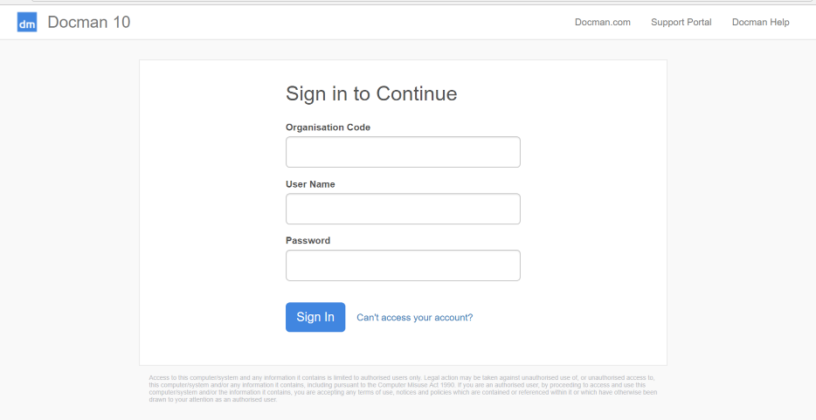
- You will then be promoted to insert an Organisation Code, Username and Password
- Insert your Organisation Code that was sent to you by the System Administrator
- Insert your username that was sent to you by the System Administrator
- Insert the password that was sent to you by the System Administrator
- Click on Sign In

If your organisation uses single sign on navigating to the screen and where single sign on has been used previously will allow the automatic sign in to Docman.

On first login you may be asked to create a new password if a temporary password has been provided
- Enter your new password into both fields and click OK.
The new password must be at least 8 characters and contain upper case, lower case and a number.

To Log Out of Docman

- From the Docman Toolbar, Click User

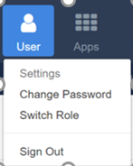
You will then be given 3 options:
- Settings – This will allow you to access back end settings if you have correct admin permissions associated with your role
- Change Password– This will allow you to change your password in the system
- Switch Role – If you have a dual role within the system e.g. Caldicott Guardian and Clinical Role selecting switch role will allow you to move to full permissions under your other assigned role
- Sign Out – Clicking sign out will log you out of Docman and you will be required to login again to access the system

Docman Inbox’s and Reviewing Tasks in Docman

Tasks

The section covers how to access Tasks that have been received for clinical review.

- You can access you Tasks by selecting the Tasks icon on the toolbar

The workflow tile will be Green to indicate you have workflows to view and Red if there are any High Priority or overdue workflows to view.

- This will open your Task window

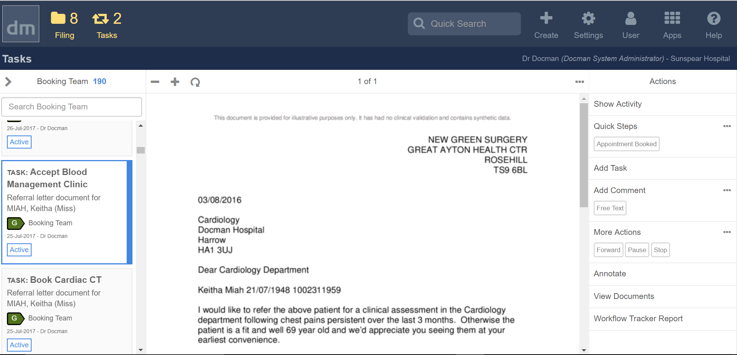
Your inbox is on the left-hand side of the screen and can be opened to allow you to see and filter tasks that you have received

Inbox and Views

The section covers how you access the different inboxes and views of Tasks that have been received for clinical review
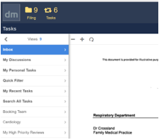
- Inbox – All documents in your inbox
- Your personal tasks
- Your recent tasks
- Search all tasks
- Tasks by groups that you are a member of
- High priority tasks that need review

You will be sent tasks to you as an individual or to the group/s you are a member of
- To view your own tasks, select personal tasks
- To view tasks for a group you are a member of select that group – Example you may be a member of Neuro Surgery and a member of Neurology therefore will have to views for each group

Selecting and Reviewing a Task
The section covers how to select and review a Task that have been received for clinical review.

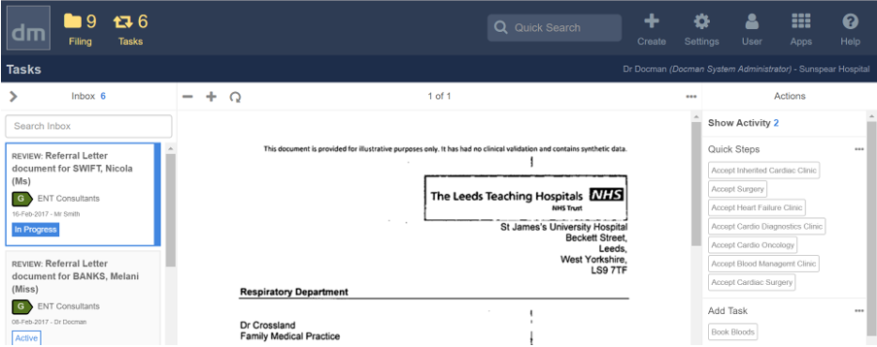

- Select a document in your inbox
- The Clinical Correspondence document will preview in the middle section of the screen
- All Actions that you can complete in relation to this task will appear on right hand side

Show Activity
The section covers how to view the history of a Task that you have received for clinical review and the activity that has been added to the task

- Select a document in your inbox
- Click Show Activity
- The activity that has taken place on this document will be shown on the right-hand side of the screen
- To remove the activity click Hide Activity to return to your task review

Add a task
The section covers how to add a task to during your clinical review of the document.

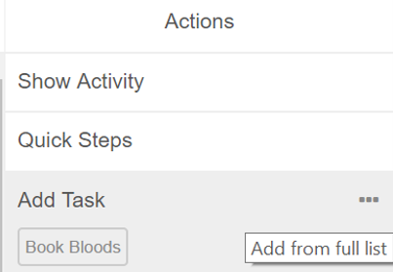

- Select a document in your inbox
- You will see your favourite tasks showing within the Add task section
- Click the required task to add to review or select … to search for required task
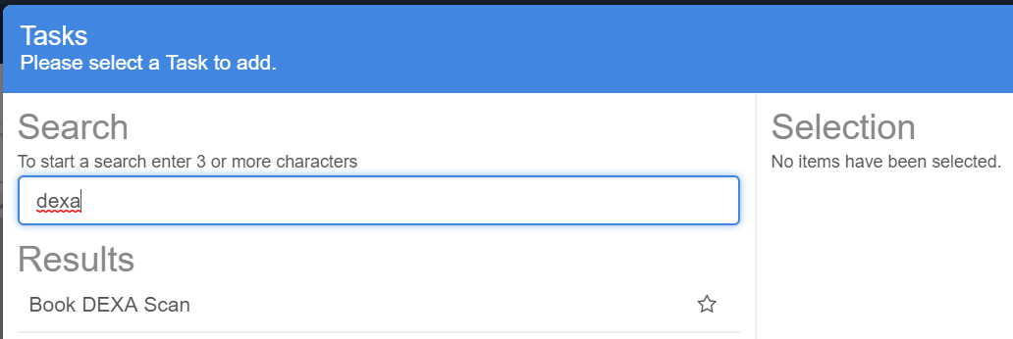
- Insert search criteria and click enter

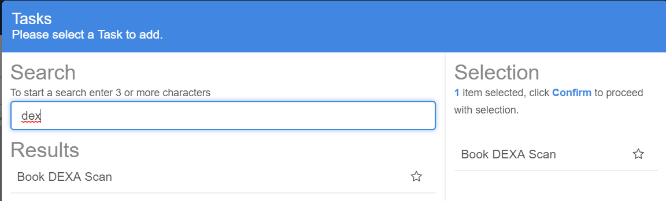
- If you wish to use task one, select task to move to selection pane and click confirm

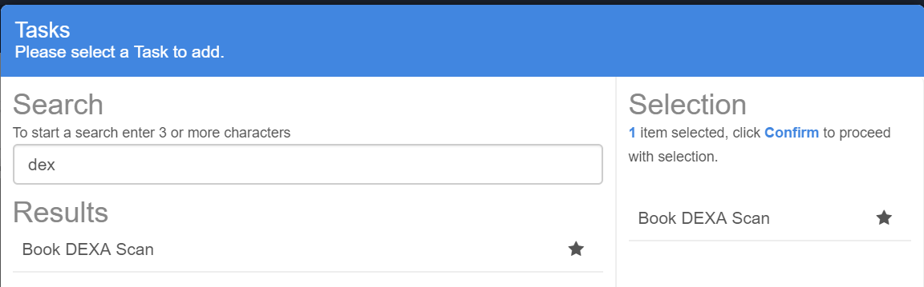
- If you wish to use this task regularly and make a favourite, select the star and click confirm

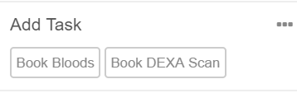
- This will then appear on you main reviewing screen

Add a comment
The section covers how to add a comment to during your clinical review of the document.

- Select a document in your inbox
- You will see your favourite comments showing within the Add Comment section
- Click the required comment to add to review or select … to search for required Comment
- Insert search criteria and click enter
- If you wish to use comment one, select comment to move to selection pane and click confirm
- If you wish to use this comment regularly and make a favourite, select the star and click confirm
- This will then appear on you main reviewing screen

Quick Steps
The section covers how to use a quick step to include and outcome of your clinical review of the document. Quicksteps allow multiple tasks, actions, comments to be used in one click.

Using a favourite quickstep

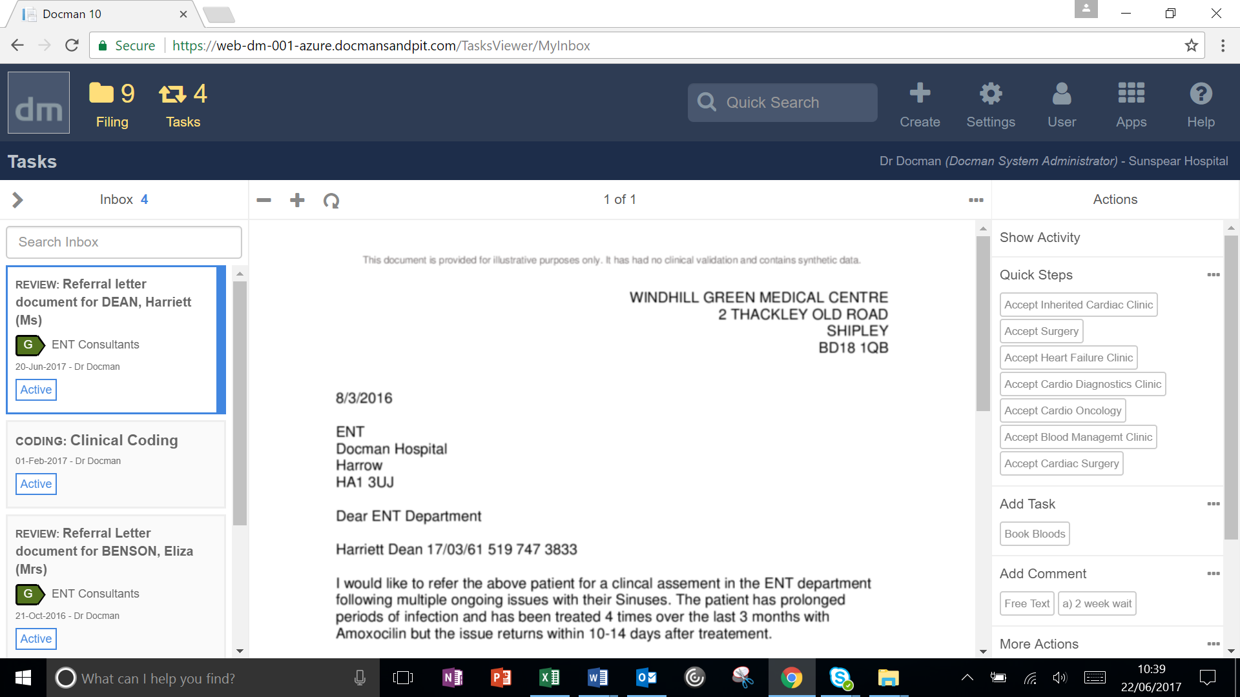

- Select a document in your inbox
- Use an appropriate quick step to complete the clinical review
- You will see your favourite Quick Steps and Quick Steps associated with the category of the document that has been sent to you
- Click the required Quick Step Example select “Accept into Clinic” to add the outcome to the correspondence
- You will then be presented if required to confirm timescales, any bloods or x-rays required if mandatory as part of the quick step
- Once quick step used your screen will refresh and you will be able to triage the next clinical correspondence in your inbox

Categories to view specific quicksteps

- Select a document in your inbox
- You will be shown the appropriate quick step to complete the clinical review by the category of the document
- For example, you may receive a document that is marked as Cardiology therefore you will see relevant cardiology quicksteps.
- If the category is incorrect and needs adjusting to allow relevant quicksteps to be shown this can be changed
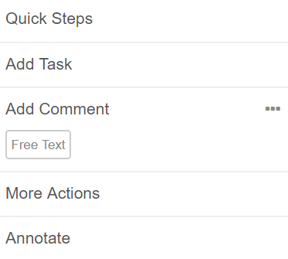
- Click More Actions
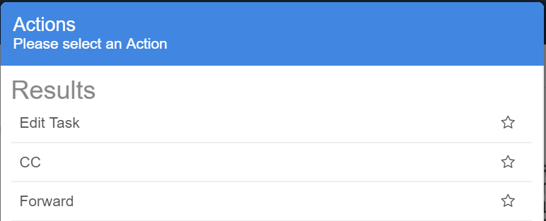
- Click Edit Task
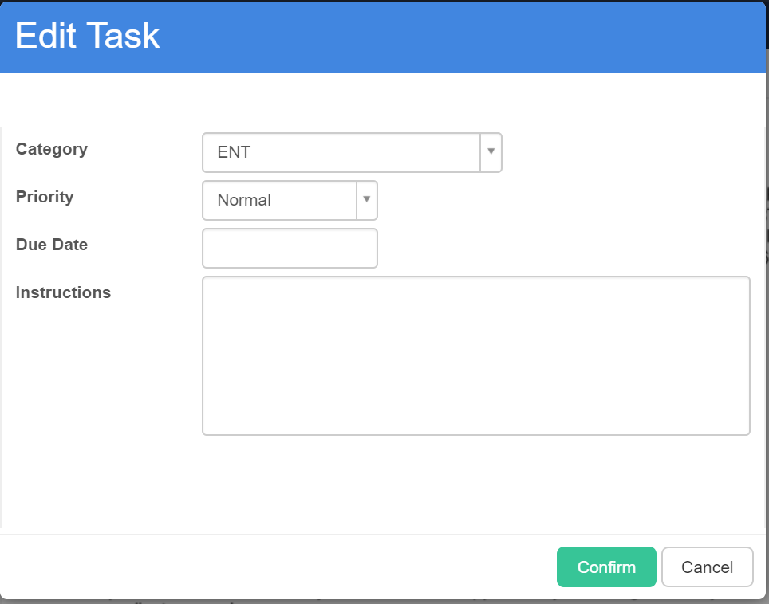
- Select appropriate Category from drop down
- Click Confirm
- This will adjust the category of the task and show you required quicksteps

Searching for a quickstep
- You can search for a quickstep if not showing in the Quick step section
- Select … to search for required quickstep
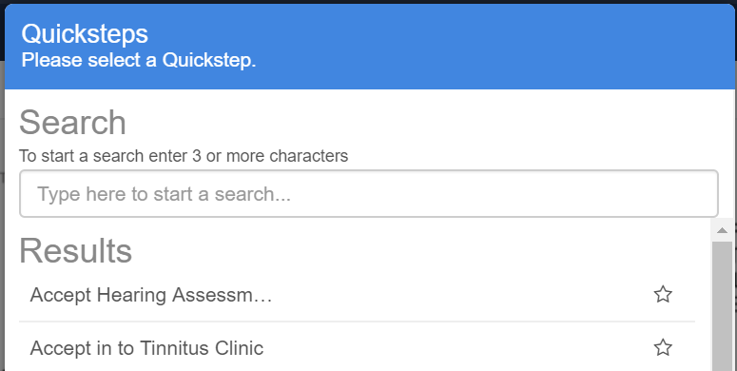
- The quicksteps assigned to you that can be used will be shown

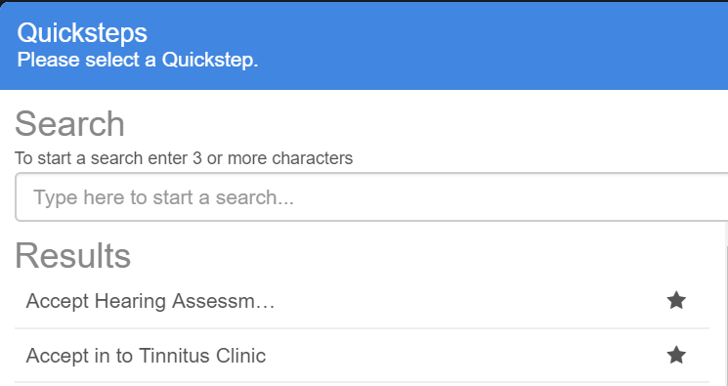
- If you wish to use this quick step regularly and make a favourite, select the star and click confirm
- This will then appear on you main reviewing screen

Forward and CC
The section covers how to forward or cc a colleague into a task

- Select a document in your inbox
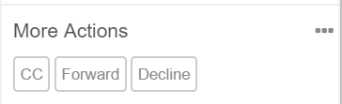
- Select the required forward or cc in the more actions review panel

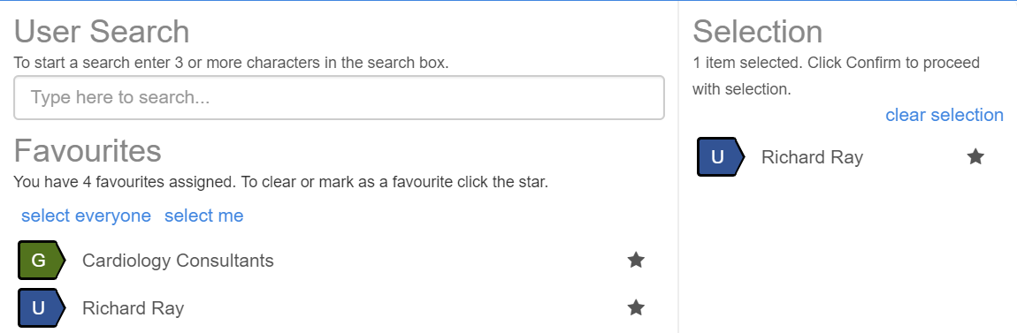

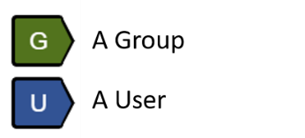

- Within the Forward or CC box it will show you your favourite users and allow you to search for a Docman user to CC or Forward clinical correspondence to
- Once selection made the user or group will appear in selection panel
- Click confirm

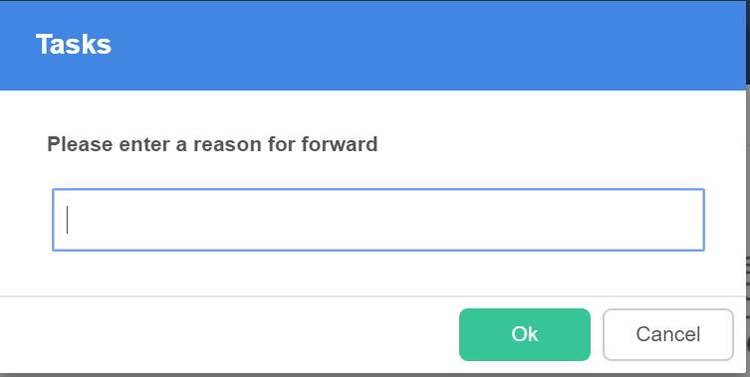

- You will be prompted for reason for forwarding a referral on to another user

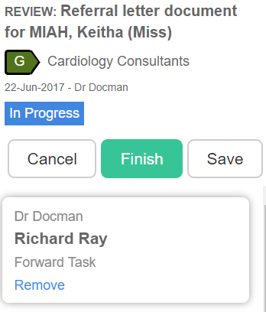

- Click Finish to complete the action will be sent over to another user

Annotate
The section covers how to annotate a Clinical Correspondence that you are reviewing.

- Select Annotate from the action panel on the right-hand side

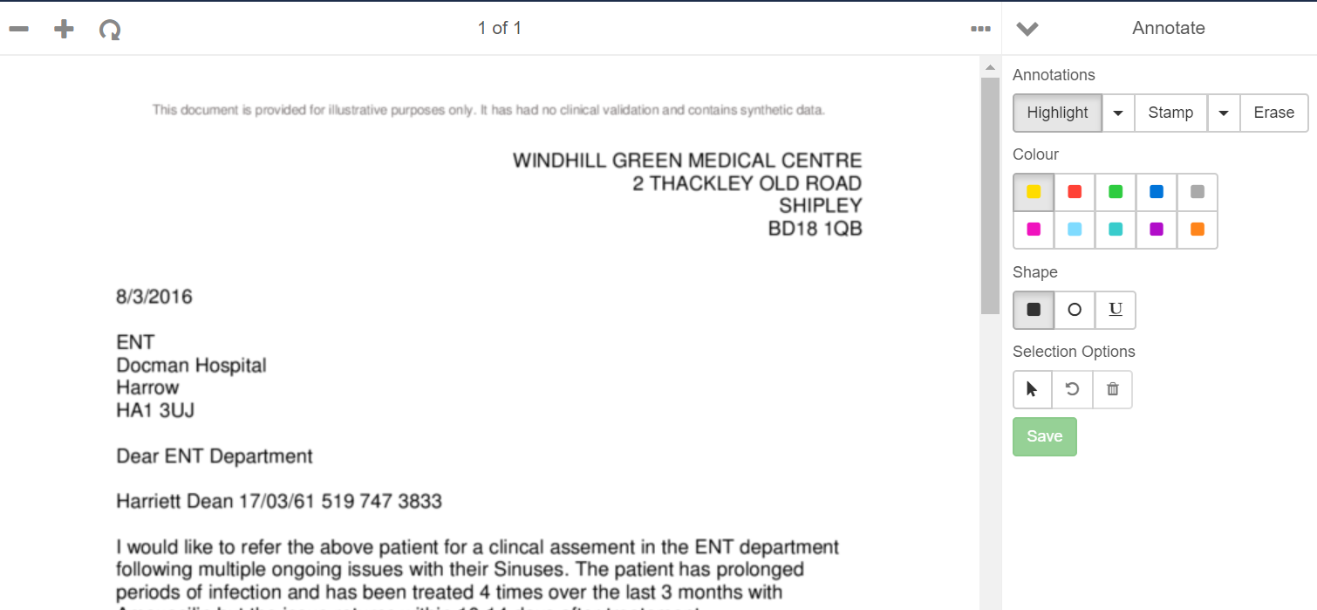
Highlight
- Select highlight and colour required
- Select Shape
- Highlight required text within the document
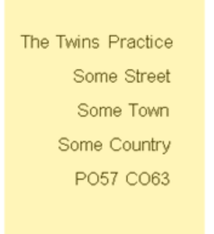
- Once highlighted click save

Stamp
- Click Stamp
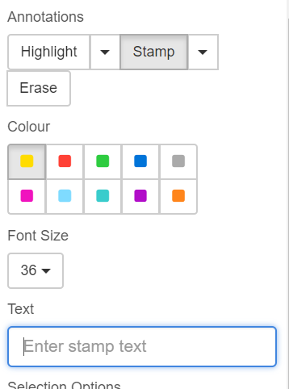
- Choose stamp colour
- Choose Font Size
- Insert stamp text
- Click Save
- Click area of screen to insert stamp

Recent Tasks
The section covers how to access and adjust recent tasks that you have reviewed that you wish to make alterations to.

- Select your inbox views
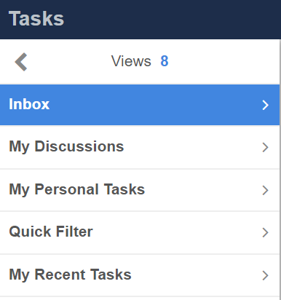
- Select my recent tasks
- This will show you the tasks that you have recently actioned and reviewed
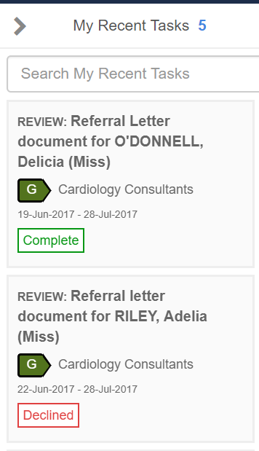
- Select required task
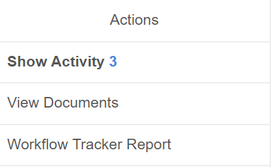
- Select View Documents from the Action Panel

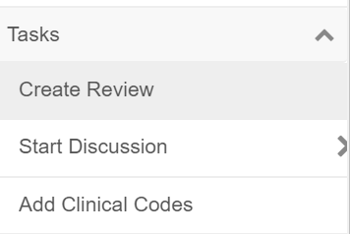
- Select Task drop down and select create review to edit the task select create review
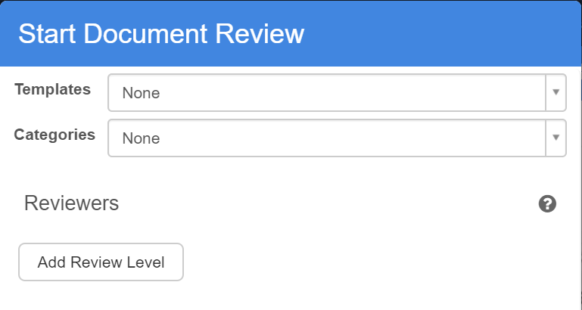
- Select Add Review Level
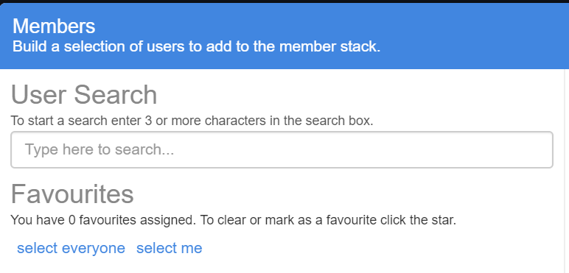
- Select Me
- Click Confirm
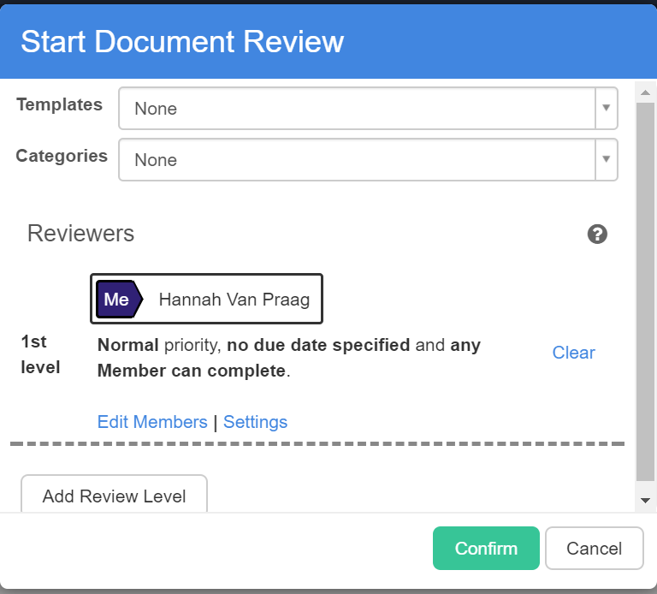
- Click Confirm again to confirm all the details
- Pop up shows review created
- Return to inbox to adjust review and add required information to task

View Documents or History of a Document in Docman

View a Patients Documents
The section covers how to search for patient documents

Search for a specific patient’s document
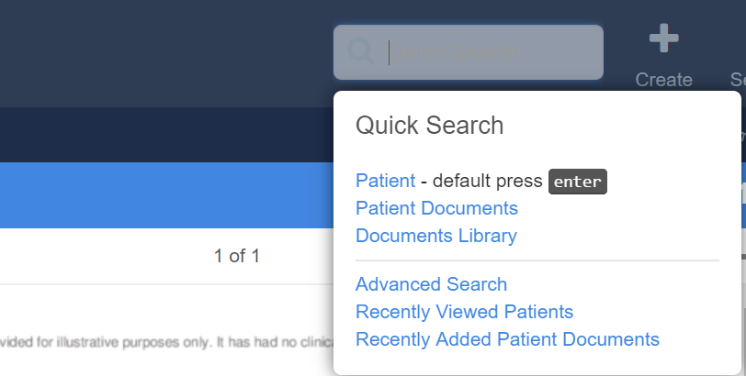
- Select Quick Search from the toolbar
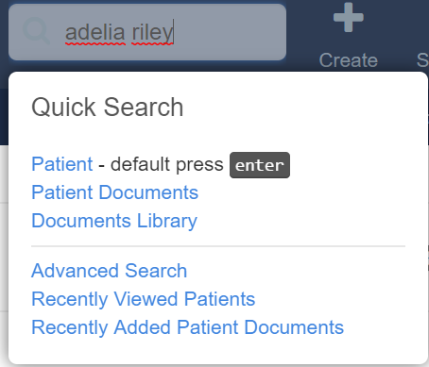
- Insert patients details and click enter
- The patient/s that match the search criteria is then shown
- Double click on correct patient to view all the documents for this patient
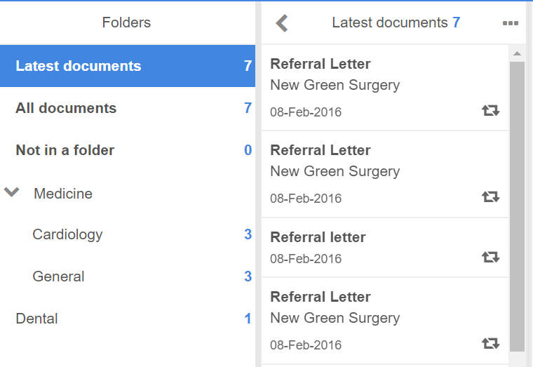

- As well as seen all documents for the patient you are also able to open the folder structure to see documents for a specific speciality only

View History of Document
The section covers how to view the history of a document

- Search for patient and specific document
- Select the document that you wish to view history
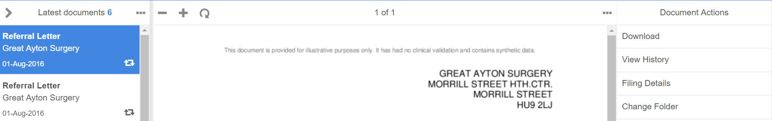

- Select View History from Document Actions panel
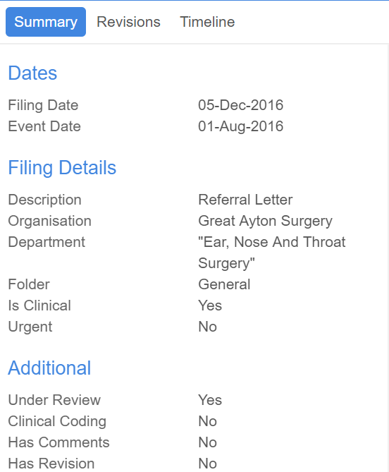

  - Summary – Provides summary of document including date filed, event date, department, priority, under review to help determine if it is still being reviewed, has comments, has revisions

  - Revisions – will notify you and show revisions made to document

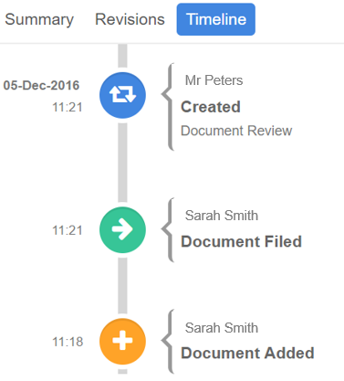
  - Timeline - will show a pictorial timeline of what has taken place with the document since it was added to the system

Discussions

Start a Discussion
The section covers how to create staff discussions this allows you to discuss patient care as well as general information in a secure discussion platform.

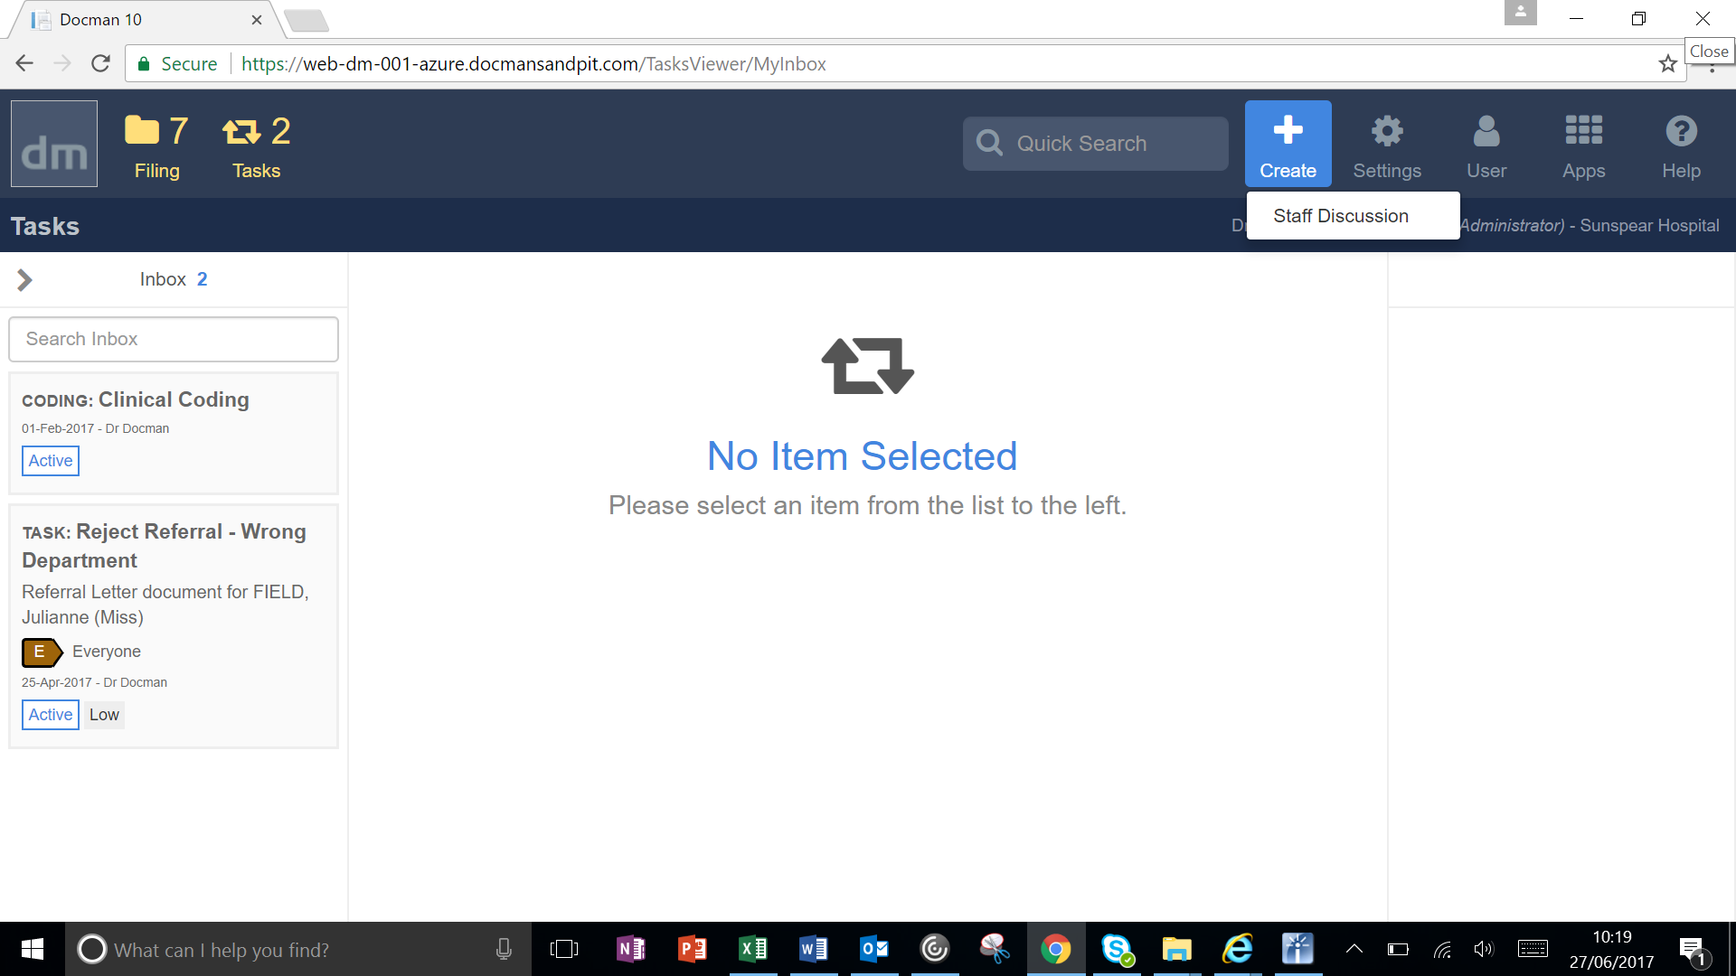

- Select create from Main screen toolbar
- Select Staff Discussion
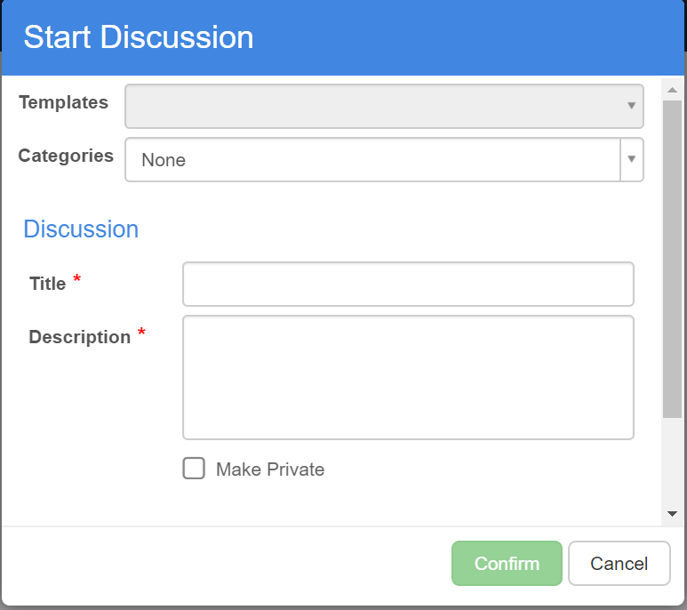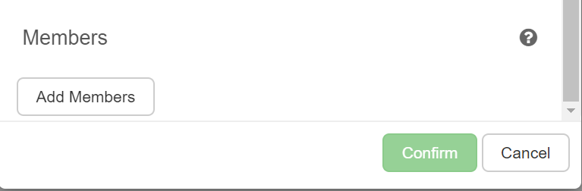
- Insert Title
- Insert Description
- Click Add members to confirm other members to take part – This could be a user or a group
- Tick if required to be made private to prevent it being searched for
- Click Confirm

- Pop up appears confirming that your discussion has been created

Access a Discussion
The section covers how to access a staff discussion you have created or been invited to or created

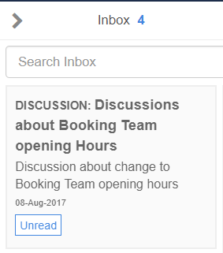

- Select inbox this will show all tasks and discussions
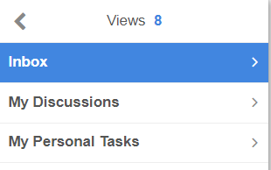
- You can filter your view and see just discussions in inbox
- Select discussion and you can add comments or documents to a discussion
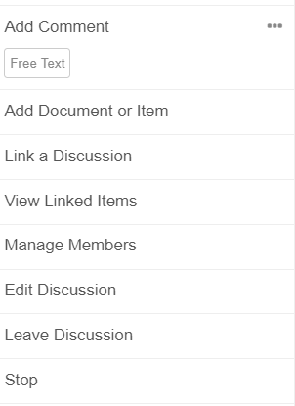
- Add comment – Free text comment
- Add Document or item – This may be a document saved against patient record, or document stored to document library
- Link a Discussion – This allows you to link this discussion to existing discussion
- View linked Items – This allows you to view linked discussions
- Manage Members – This allows you to add or edit the members
- Edit Discussion – if you are owner of discussion
- Leave discussion – If discussion is not appropriate for you to be part of
- Stop Discussion – This stops the discussion for all users

Additional Help and Docman Resource Material
Additional help resource can be found on Docman help website

http://help.docman.com/

