Docman 10 RMS Scan and Filing User Guide

Docman 10 RMS Scan and Filing User Guide
Version: 0.4
01 November 2017

Document Information

History
Date | Author | Stage | Description | Version
24/02/2017 | Hannah Van Praag | Initial Draft | Creation of first draft. | 0.1

Copyright
© The copyright in this document is owned by PCTI Solutions Limited, including (without limitation) in all alpha-numeric text and code, images, schematics and illustrations. No part of this document may be reproduced, stored in a retrieval system, or transmitted in any form or by any means without the express written consent of PCTI Solutions Limited.

Exclusion of liability
The information in this document is provided for information only and is subject to change without notice. While we make strenuous efforts to ensure that the content of this document is accurate and up to date when published, PCTI Solutions Limited gives no warranty on its accuracy and assumes no responsibility or liability for any errors or inaccuracies whatsoever (to the extent such exclusion is permitted by applicable law).

Ownership
For more information on the content or status of this document, please contact the person identified below:
Name  Hannah Van Praag  Professional Services Manager  E-mail: hannhvanpraag@docman.com  Tel: 07808 241035 | Docman  Pioneer Court  Pioneer Way  Whitwood, Castleford, West Yorkshire,  WF10 5QU  Tel: 01977 66 44 88

Docman RMS/ EDM User Guide Plan

Scanning and Filing
This user guide is designed for users who are going to scan and file clinical correspondence into Docman and send to required speciality for action.
Contents
Logging In/Out of Docman 4
Scanning and Filing Documents 6
Types of Clinical Correspondence 6
Scanning clinical correspondence into Docman 7
Annotating or adjusting documents in Batch Manager 8
Renaming a Batch 9
Deleting Documents from Batch Manager if scanned incorrectly 9
Filing Documents Without using Intellisense 10
Duplicate Clinical Correspondence 12
Manual Filing Templates 13
Filing Documents with Intellisense 15
Adding a key word to existing template 18
Workflow Documents 19
Workflow Views 21
Searching for Documents 21
Edit Filing Details 23
Printing Clinical Correspondence 26

Accessing Docman

To log in to Docman

- Access the internet
- Access your Docman URl Link
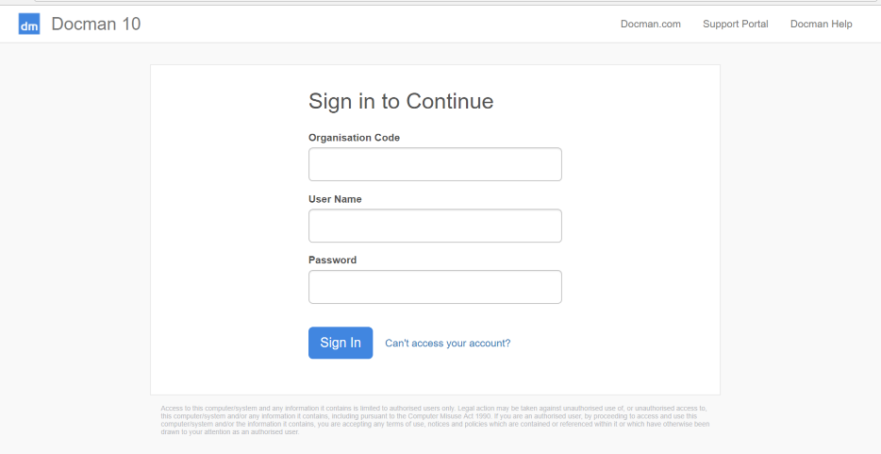
- You will then be promoted to insert an Organisation Code, Username and Password
- Insert your Organisation Code that was sent to you by the System Administrator
- Insert your username that was sent to you by the System Administrator
- Insert the password that was sent to you by the System Administrator
- Click on Sign In

If your organisation uses single sign on navigating to the screen and where single sign on has been used previously will allow the automatic sign in to Docman.

On first login you may be asked to create a new password if a temporary password has been provided
- Enter your new password into both fields and click OK.

To Log Out of Docman

- From the Docman Toolbar, Click User

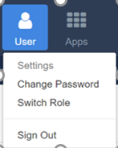
You will then be given 3 options:
- Settings – This will allow you to access back end settings if you have correct admin permissions associated with your role
- Change Password– This will allow you to change your password in the system
- Switch Role – If you have a dual role within the system e.g. scanner and file role and system admin, selecting switch role will allow you to move to full permissions under your other assigned role
- Sign Out – Clicking sign out will log you out of Docman and you will be required to login again to access the system

Types of Clinical Correspondence

Depending on your organisation setup, you may receive from multiple sources in batch manager to file:
- Two Way hub – Received electronically
- Choose and Book (ERS) – Received electronically
- Electronic Fax – Received electronically
- Email – Dedicated email receiving directly into Docman
- Scan – User would need to scan directly into Docman as detailed below

Scanning and Filing Documents
The section covers how you would scan and file documents into Docman

- Docman 10 is web-based. The only local element of Docman that is a Desktop Service is the ability to scan into the system
- You will need to have Docman 10 Desktop App downloaded onto your machine

How to scan into Docman

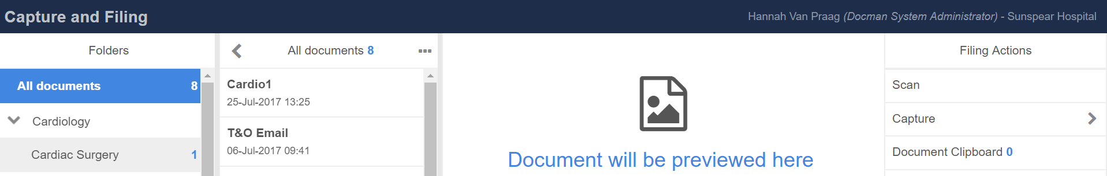

- Access Capture and filing screen
- Click Scan
- This then launches the Docman Desktop App

To Capture from a Scanner
- Click capture from Scanner on desktop App
- Select Scanner Source
- This will start the scanning using attached scanner
- Can scan to a dedicated to folder
- Can scan and file into Docman in one go
- If you scan 10 pages and wish to separate out these clinical correspondence into multiple patient records select the pages using single click in desktop app
- Click File to file immediately into Docman

Or select send to folder to allow them to be sent into Docman folder from desktop app

Annotate
The section covers how to annotate a Clinical Correspondence that you are reviewing.

- Select Annotate from the action panel on the right hand side

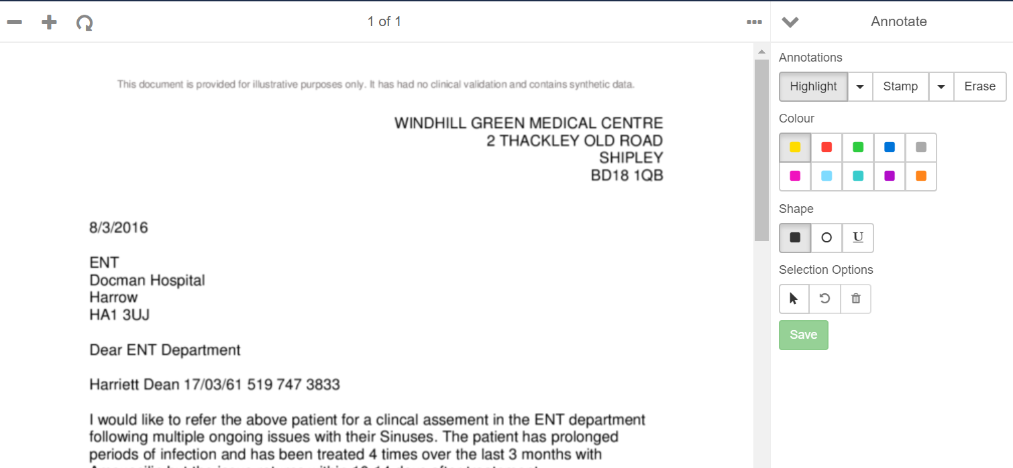
Highlight
- Select highlight and colour required
- Select Shape
- Highlight required text within the document
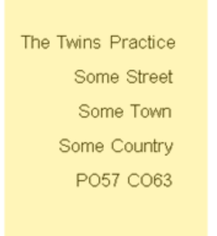
- Once highlighted click save

Stamp
- Click Stamp
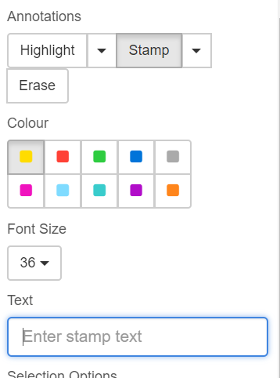
- Choose stamp colour
- Choose Font Size
- Insert stamp text
- Click Save
- Click area of screen to insert stamp

Renaming a Document
The section covers how to Rename a document

Add a Document to a Pre- Filing Folder/ Moving Document to new Pre- Filing Folder

The section covers how to Add a document to a folder or move a document to a new pre filing folder

- Select the document that you wish to add to a pre-filing folder
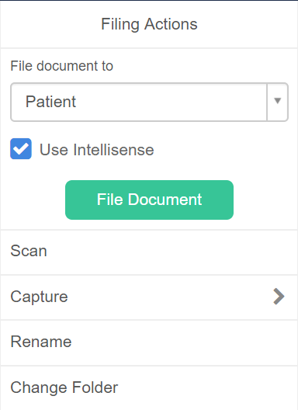
- Select Change Folder from Filing Actions Panel
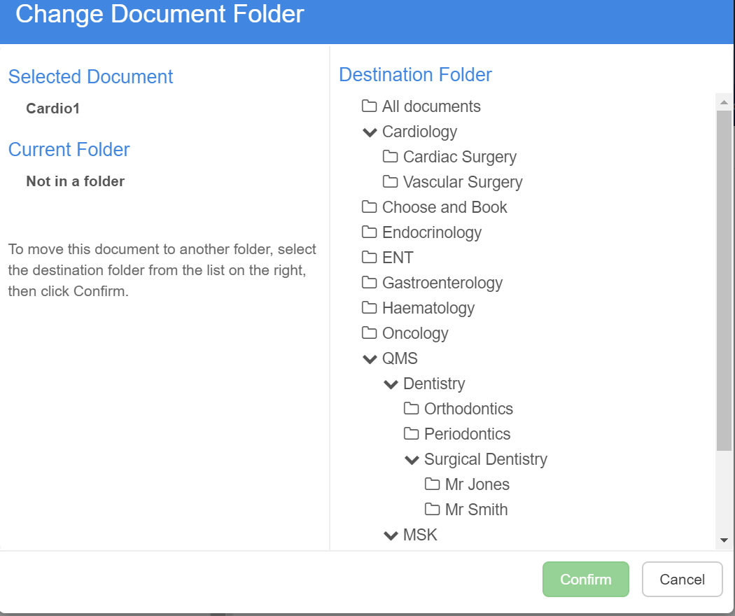
- Select required folder
- Click Confirm
- Pop up notification to tell you that folder of the document has been changed

Filing Documents with Docman
The section covers how to file a document into Docman system

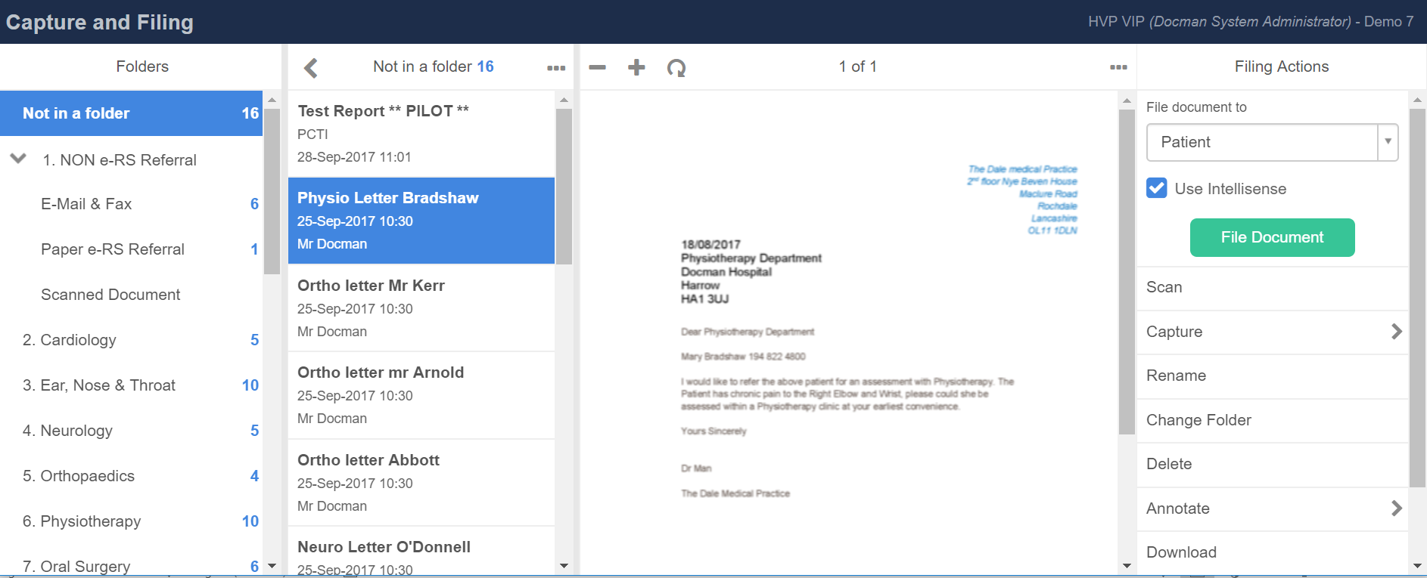

- Select a document in the capture and filing screen
- Highlight to use Intellisence (this will assist in the filing process and read letter for you to assist in filing into Docman)
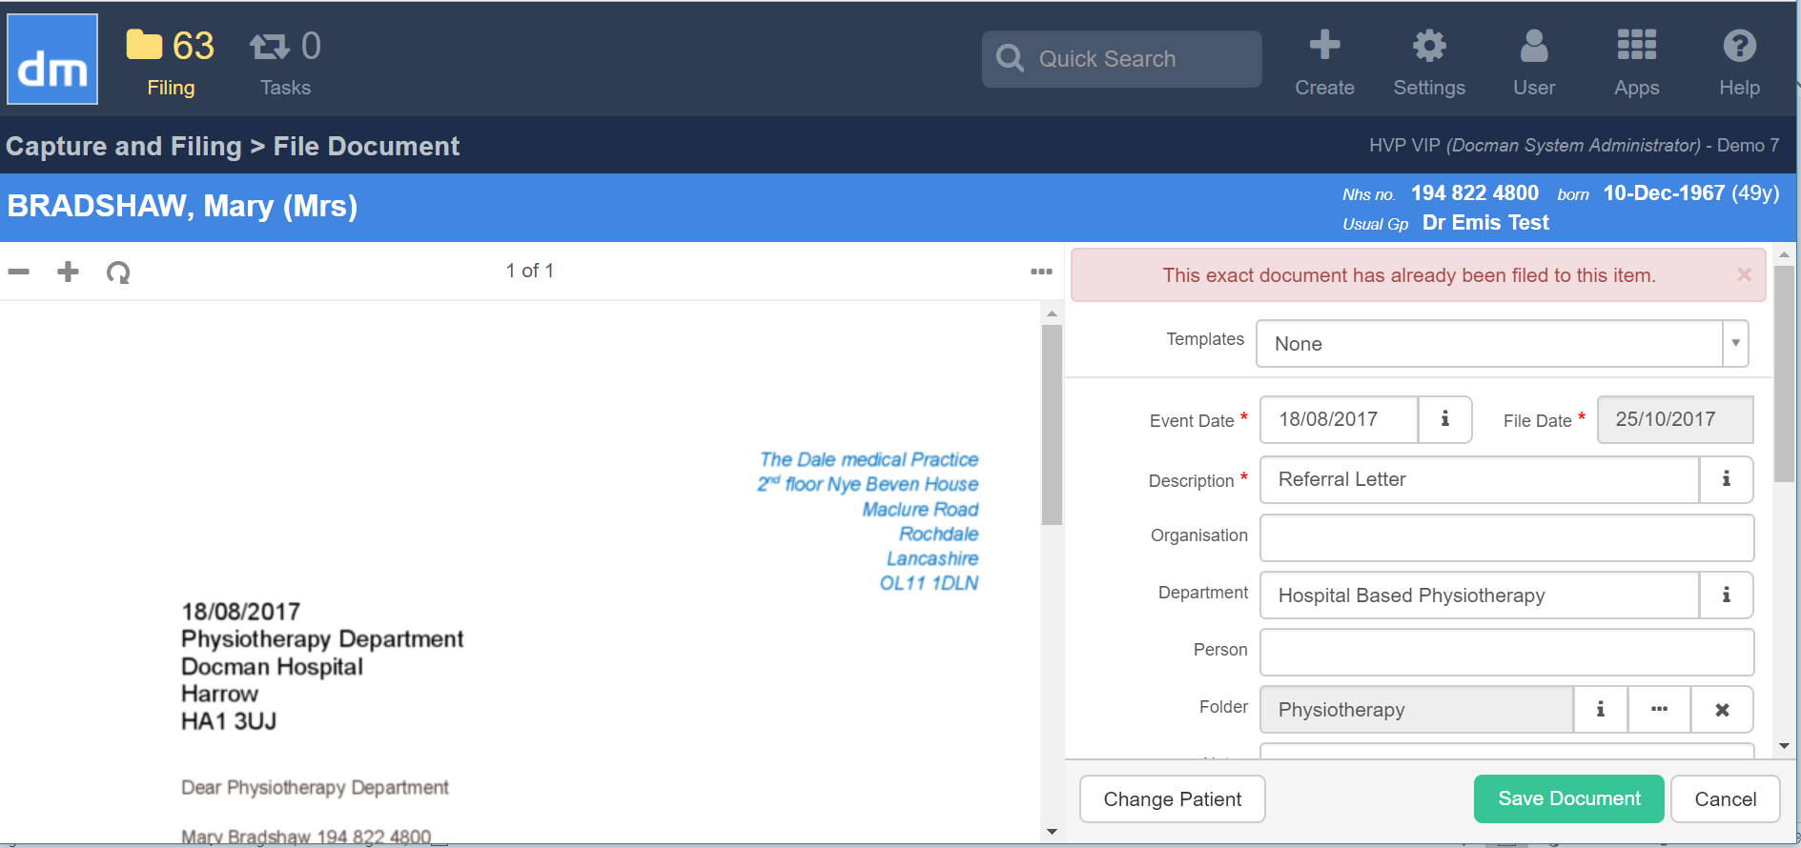
- You are able to file by selecting a filing template to assist with the process (this will pre-populate the information in the File Document Screen)
- The mandatory fields are marked by a * against the filing details screen
- Once completed click save document (the document is now filed against the patient record in Docman)
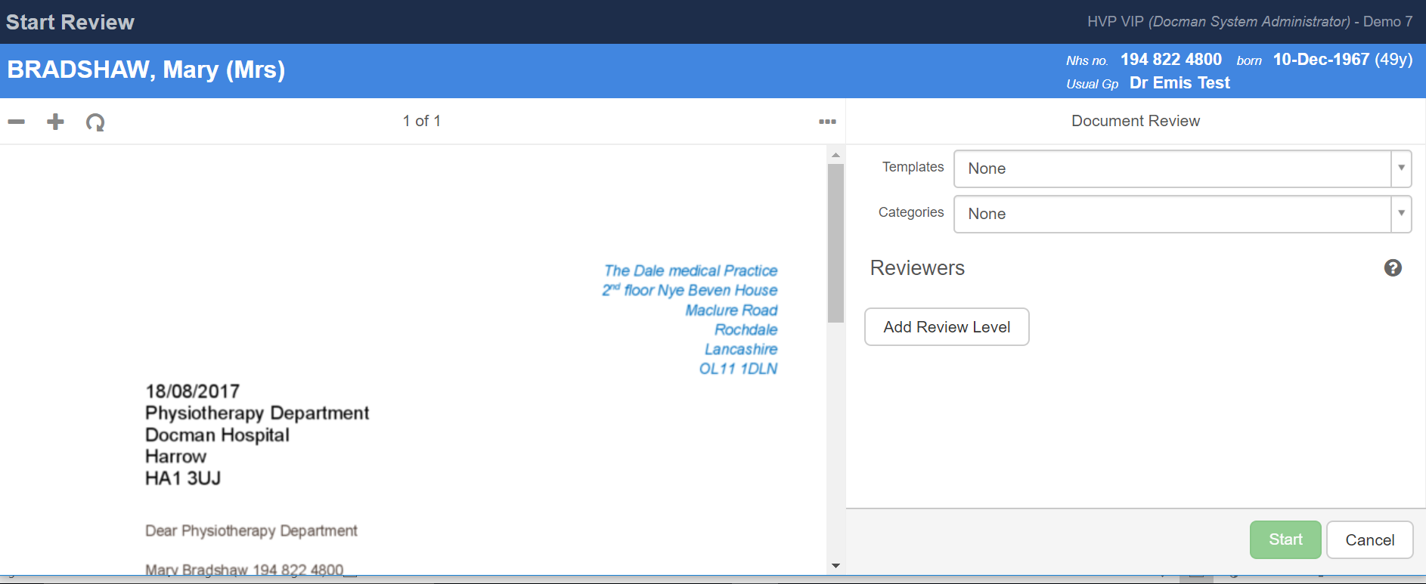
- You need to then select the review that needs to be completed – who needs to review the letter.
  - This can be completed by using a review template or by adding a review level of a user or group
  - 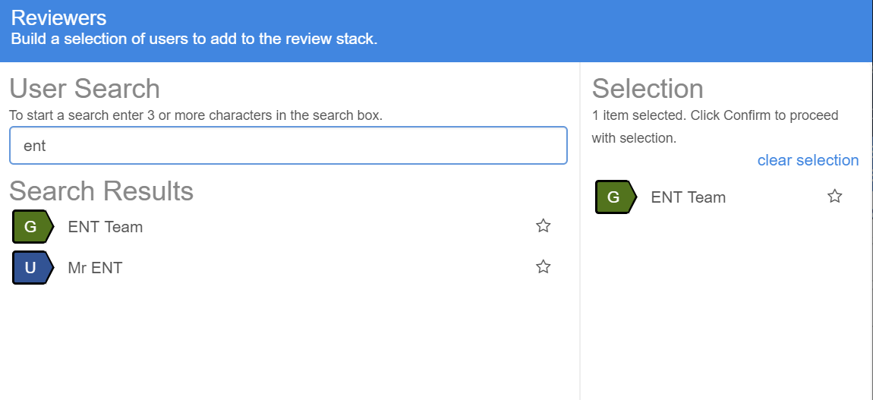
- Once user or group is selected that needs to review the correspondence
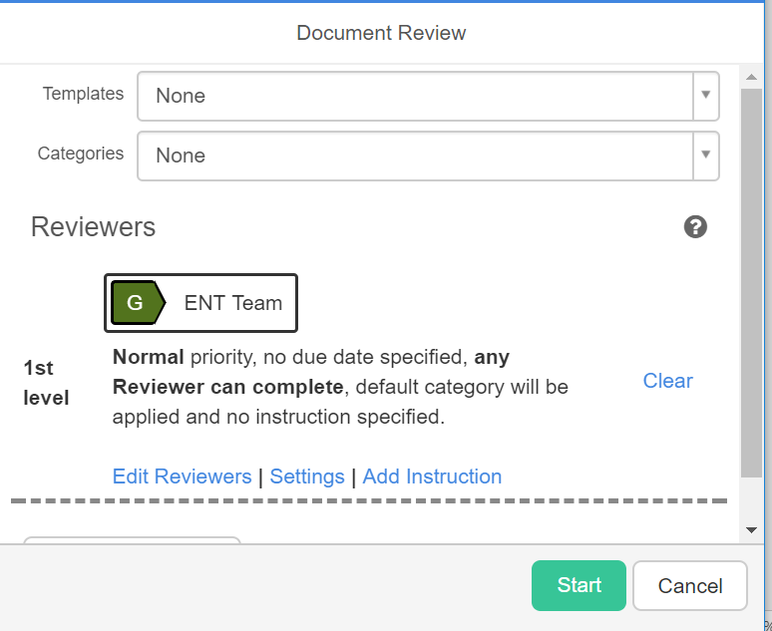
- Once information added click start to allow the document to be workflowed to the correct user or group
In sending a workflow to a group this is done and allowed one user to action on behalf of the group

Filing Documents with Filing Templates
The section covers how to file a document into Docman system using a Filing Template

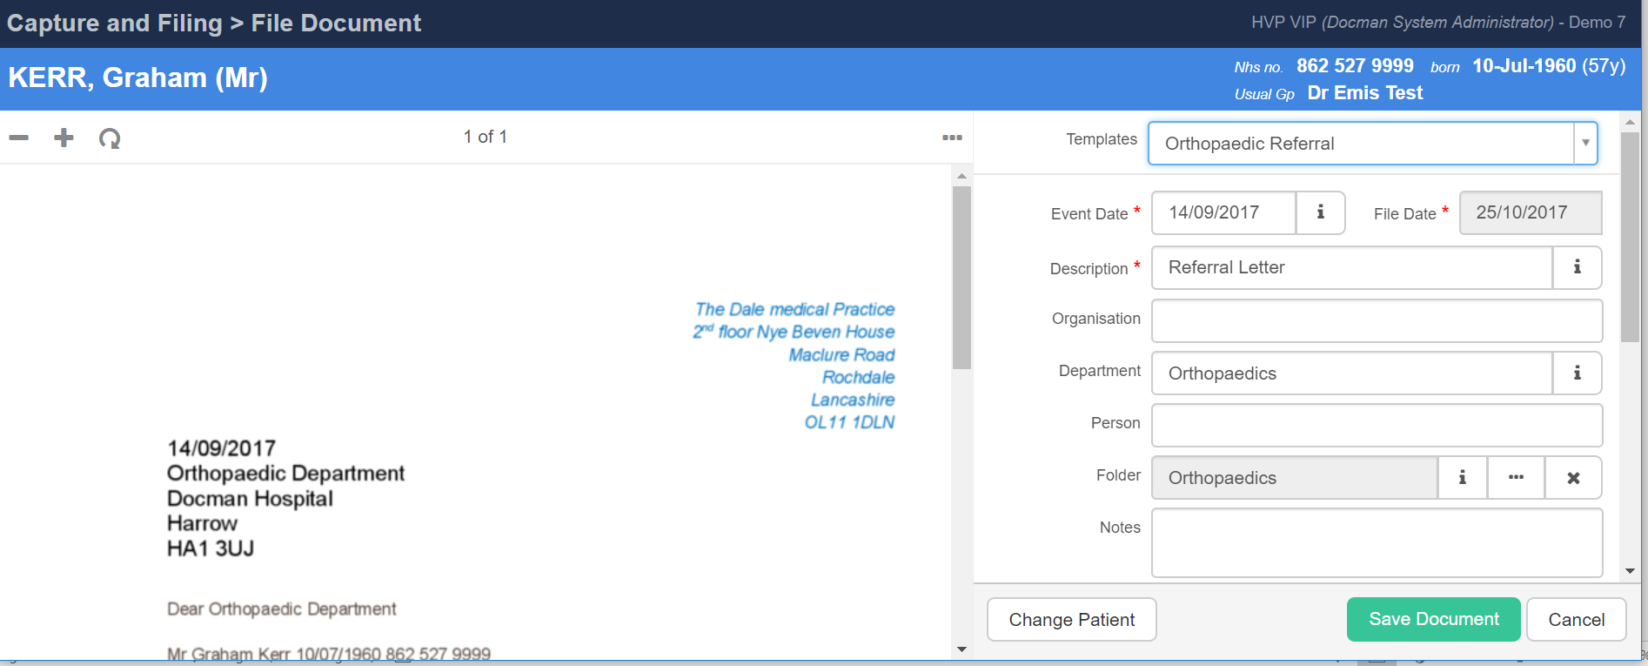

- You are able to file by selecting a filing template to assist with the process
- This allows for the filing details to be prepopulated and prevents the need to fill out the filing screen each time

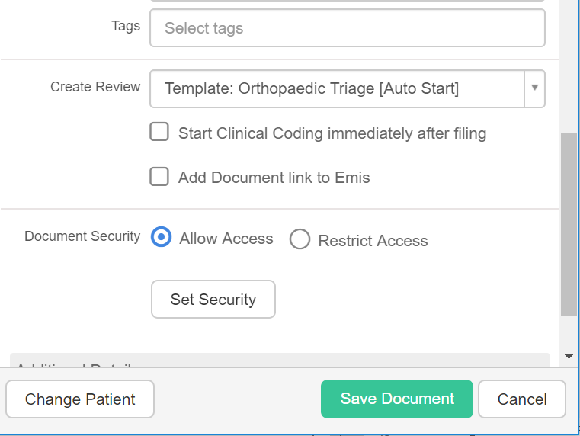
- The Filing template can also be linked to the create review section of filing and have a Review Template associated so that each time the filing template is used it will automatically send to a group or individual
- E.g. This orthopaedic filing template when used will automatically create a review and send to Orthopaedic team for triage

Filing Documents and Specifying dates and priority of a task
The section covers how to specify dates and set the priority of a task when filing a document

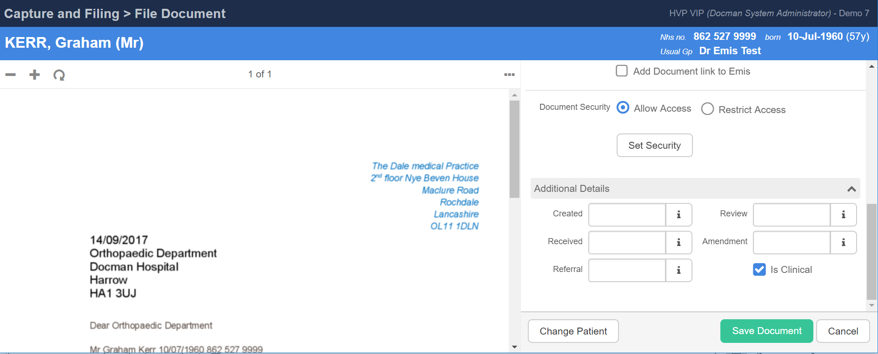

- You are able when filing a document to specify additional dates such as
- Review date – date which is review due by and will become overdue if this date passes
- Received date – This could be different to the filed date and can be used to specify the date the document was received
- Due date – This sets the date that the triage is required by and by the urgency will be visible to the document reviewer in their inbox
Please note that these dates will be used for reporting purposes for your organisation

Filing Documents to clipboard
The section covers how to file a document using clipboard within the Docman system

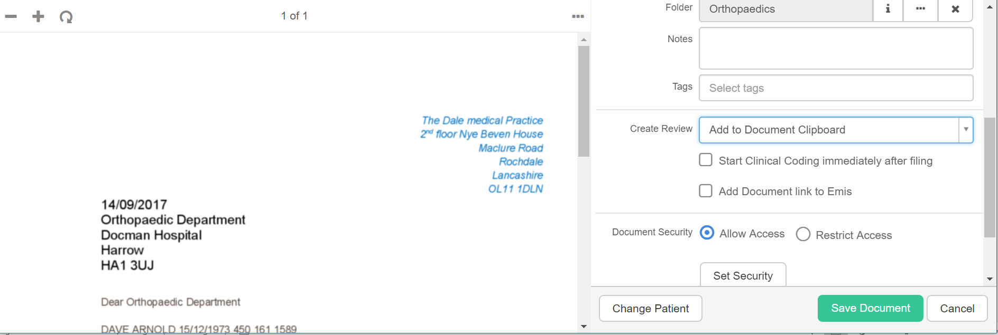

When completing the filing process you can choose to file a document and then adding it to Docman Clipboard rather than creating a review for it immediately.

This process is useful when you have multiple documents that need review by the same user or department, or if you wish to add another document o this existing document prior to sending for review.

- Select add to document clipboard
- Click save
- Complete process of filing another document to the document clipboard
- Return to capture and filing screen and you will see the amount of documents that are within your Document Clipboard

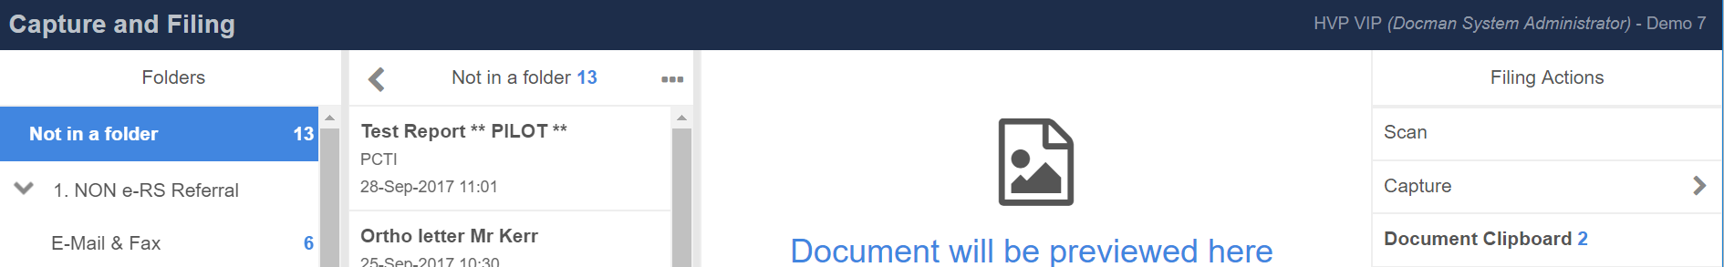
- Return to capture and filing screen and you will see the amount of documents that are within your Document Clipboard
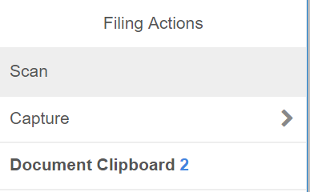
- Select the Document Clipboard
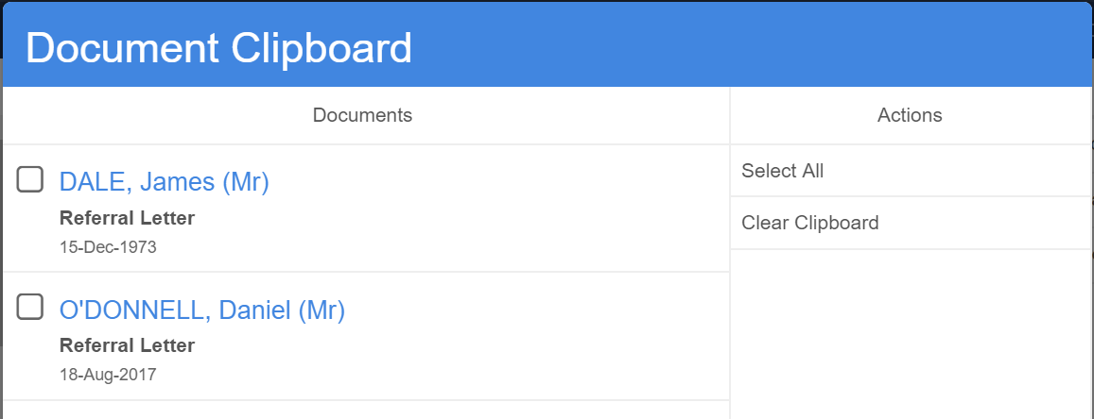
- Select individual document or use select all

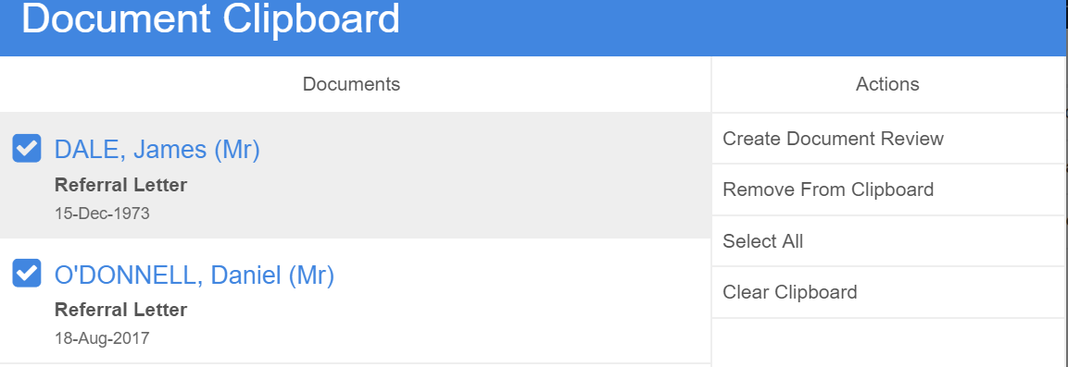
- You will then be prompted for the actions that can be completed
- To send these to a group or induvial for review
- Select create document review
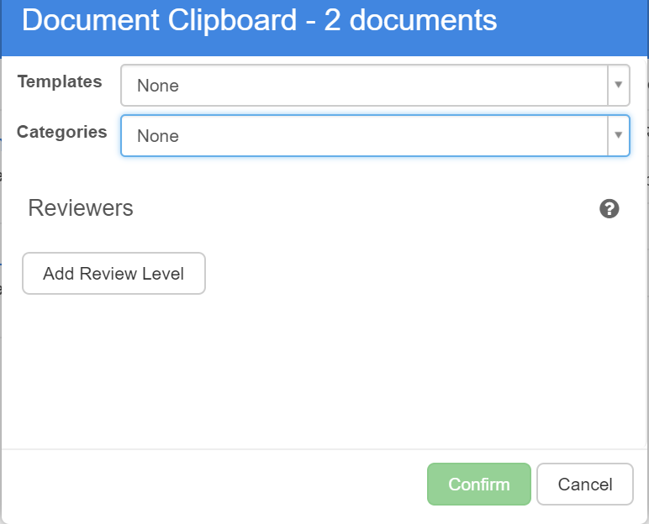
- Choose the review group or user and then the documents will be sent as a individual review tasks

View Documents or History of a Document in Docman

View a Patients Documents and Recent Documents
The section covers how to search for patient documents and how to view recent documents that you have accessed

Search for a specific patient’s document
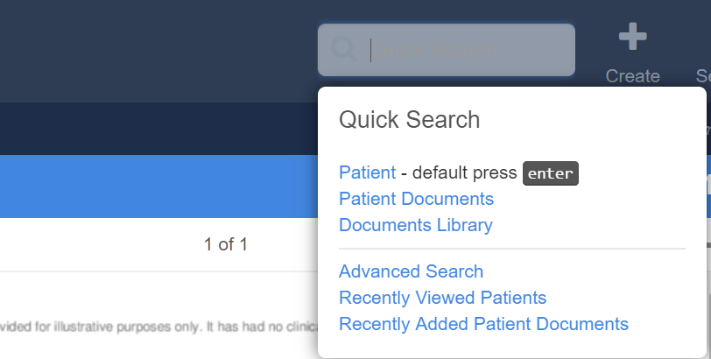
- Select Quick Search from the toolbar
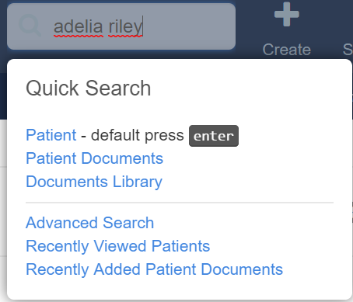
- Insert patients details and click enter
- The patient/s that match the search criteria is then shown
- Double click on correct patient to view all the documents for this patient
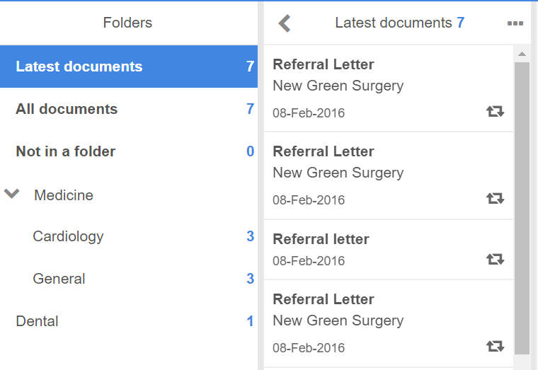

- As well as seen all documents for the patient you are also able to open up the folder structure to see documents for a specific speciality only

View History of Document
The section covers how to view the history of a document

- Search for patient and specific document
- Select the document that you wish to view history
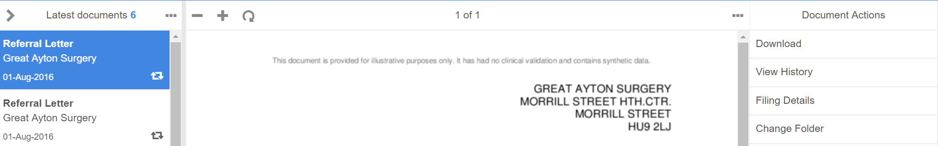

- Select View History from Document Actions panel
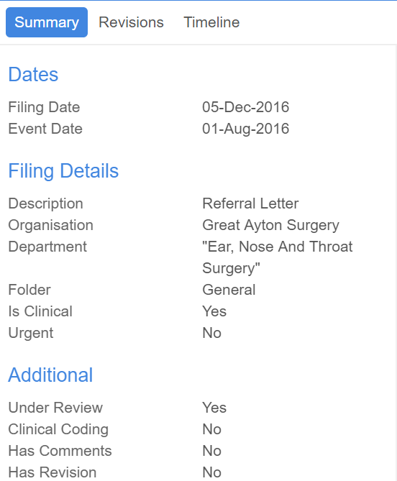

  - Summary – Provides summary of document including date filed, event date, department, priority, under review to help determine if it is still being reviewed, has comments, has revisions

  - Revisions – will notify you and show revisions made to document

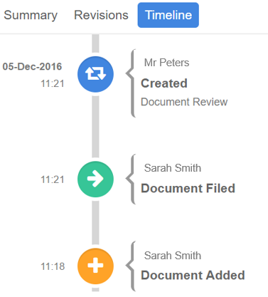
  - Timeline - will show a pictorial timeline of what has taken place with the document since it was added to the system

Edit Filing Details
The section covers how to Edit the Filing Details associated with a document

- Search for patient and specific document
- Select the document that you wish to edit
- Select Filing Details from the action panel
- This displays all the filing details and allows you to adjust the filing details so they are correct
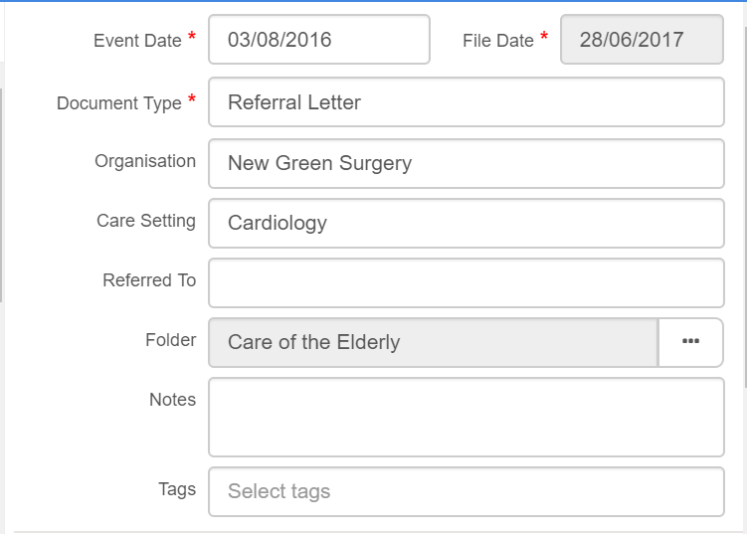
e.g. here we are going to change the folder to Cardiology as we can see in error it’s in the Care of the Elderly

- Edit the required details and click Save Document

Edit task details
The section covers how to Edit the Task Details associated with a document
- Search all tasks by patient name to find tasks associated with document
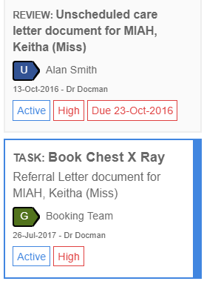
- Select Forward in actions panel
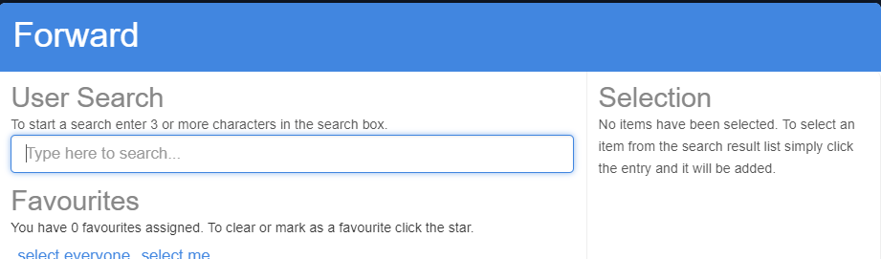
- Select required recipient to forward task to
- You will need to complete this for all tasks associated with the clinical correspondence if required

Discussions

Start a Discussion
The section covers how to create staff discussions this allows you to discuss patient care as well as general information in a secure discussion platform.

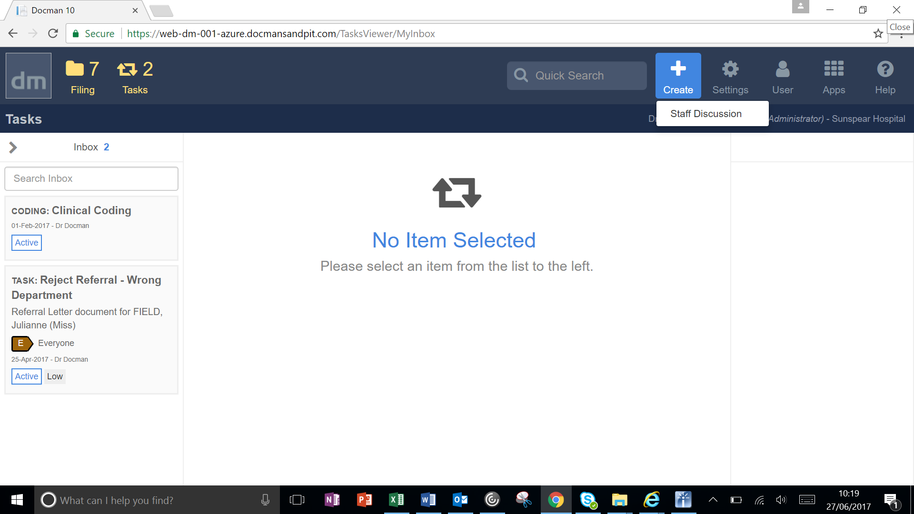

- Select create from Main screen toolbar
- Select Staff Discussion
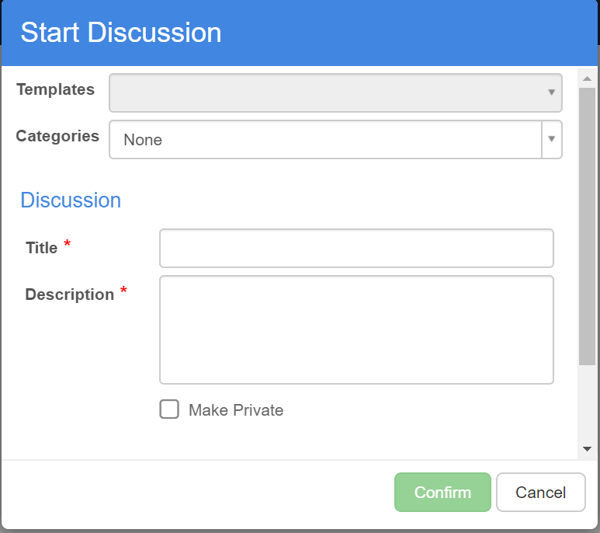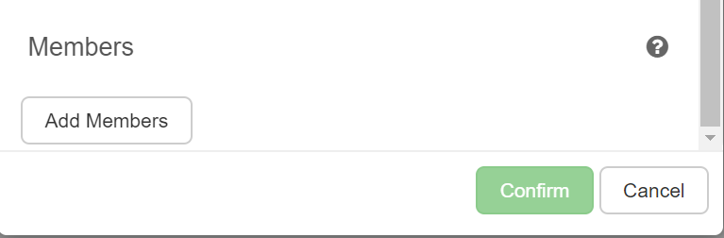
- Insert Title
- Insert Description
- Click Add members to confirm other members to take part – This could be a user or a group
- Tick if required to be made private to prevent it being searched for
- Click Confirm

- Pop up appears confirming that your discussion has been created

Access a Discussion
The section covers how to access a staff discussion you have created or been invited to or created

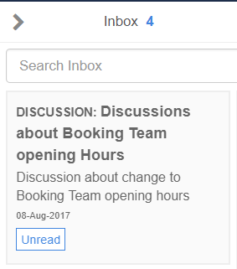

- Select inbox this will show all tasks and discussions
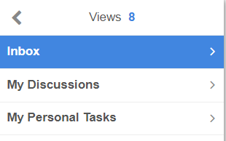
- You are able to filter your view and see just discussions in inbox
- Select discussion and you can add comments or documents to a discussion
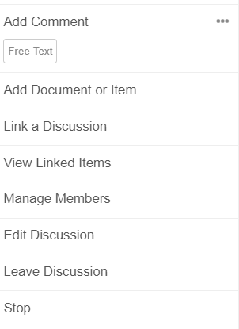
- Add comment – Free text comment
- Add Document or item – This may be a document saved against patient record, or document stored to document library
- Link a Discussion – This allows you to link this discussion to existing discussion
- View linked Items – This allows you to view linked discussions
- Manage Members – This allows you to add or edit the members
- Edit Discussion – if you are owner of discussion
- Leave discussion – If discussion is not appropriate for you to be part of
- Stop Discussion – This stops the discussion for all users

