Docman 10 ICP.2019.R3.90
Release Notes

 |  | Report created at: 12/03/2019 08:25AM
 |  |  |  | Notes / Special Instructions: n/a
 |  |  | This release contains the following items:
 | JIRA ID |  |  |  | ServiceNow  Ref | Type | Title |  |  |  | Description
 | D10-948 |  |  |  | INTERNALLY LOGGED | New Feature | (RMS Only) Barndoc Full Referral Report |  |  |  | A new feature was added as a part of the Barndoc project. A full data extract is now available.
 | D10-988 |  |  |  | INTERNALLY LOGGED | New Feature | (RMS Only) Barndoc Modifications |  |  |  | A number of changes were made as part of the Barndoc project. An area for additional information for an outcome is now accessible via the task card and a task card will have an indicator to show it has additional information. Various other tweaks to add information to the timeline such as the UBRN were added to ensure the workflow works correctly for Barndoc.
 | D10-929 |  |  |  | INTERNALLY LOGGED | New Feature | Connect Sending- Send Document via Connect |  |  |  | A new feature was added to allow customers of Docman Connect to send documents to other Docman 10, Docman 7 and non Docman Endpoints. Customers of both Docman 10 and Connect will now be able to send documents directly from Docman 10 without logging into Connect. See 1
 | - D10-930 |  |  |  | INTERNALLY LOGGED | New Feature | Connect Sending- Create Tasks for Rejected/Errored Connect Documents |  |  |  | A new feature was added to manage any documents sent via Connect that error or are rejected. Tasks will be created to notify users accordingly and prompt action
 | - D10-940 |  |  |  | INTERNALLY LOGGED | New Feature | Connect Sending– Update document audit |  |  |  | A new feature was added to update the document audit with the Connect status once a document is sent via Connect. This will allow users to track a document from within Docman 10 instead of logging into Connect.

- Send Document Via Connect
Selecting the send via Connect option
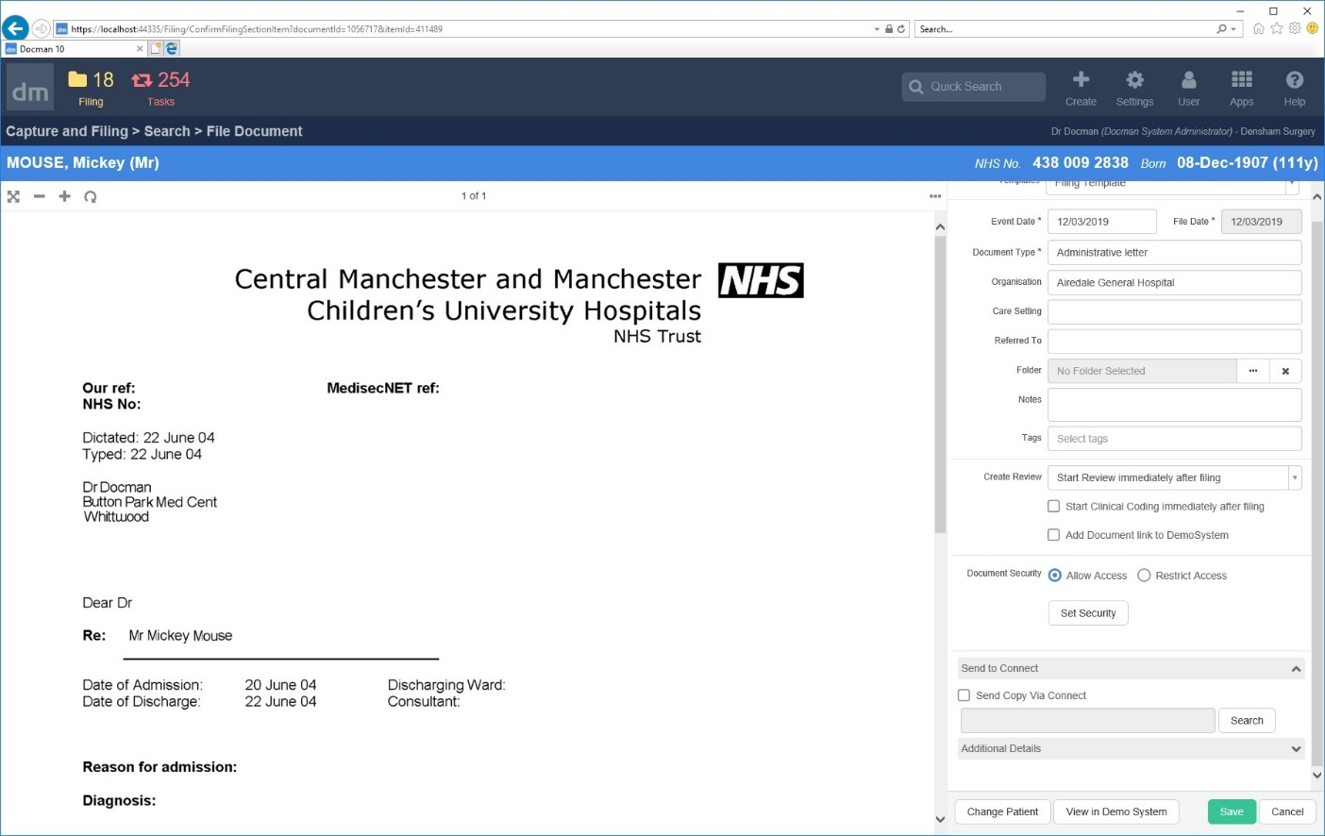

Picking the destination
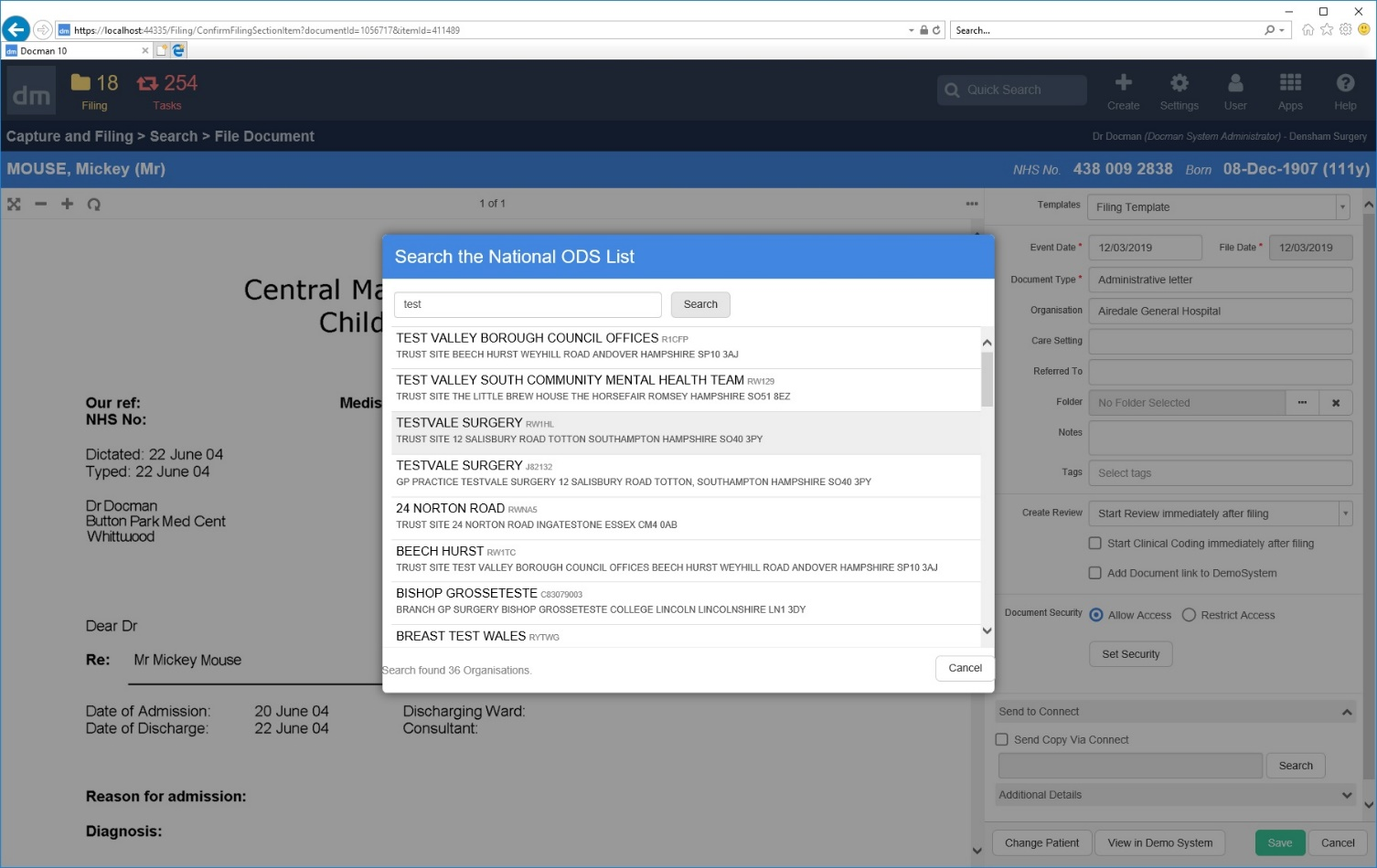

Saving the selection
