‘HOW TO’ GUIDE

User Groups maintenance

Role requirements to access the User Groups:
Docman roles: Docman System Administrator
Docman Supervisor

RBAC Roles: Systems Support Access Role

1. To access the Users folder, click on Settings on the ribbon. The Users folder is then listed on the left hand side.

2. Choose the Users folder, and the User Groups subfolder beneath it.
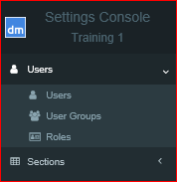

To create a new group:

3. Within the Users subfolder, choose Create in the bottom left corner.

4. Complete the screen as below and click Create.
NB: Items marked with an asterix * are mandatory fields.

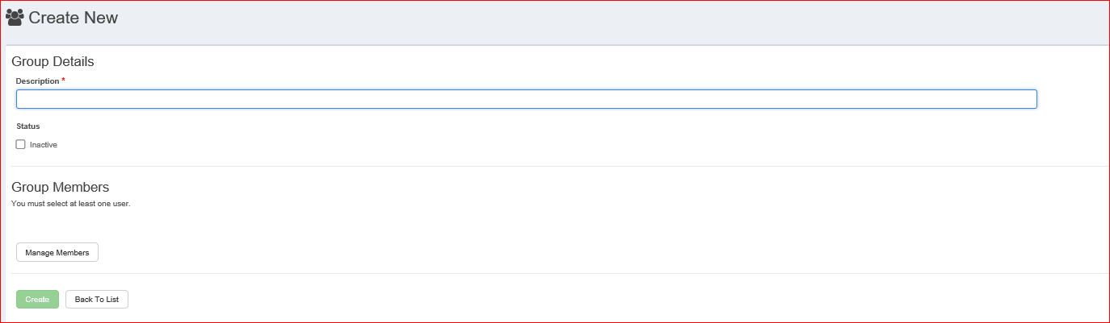

5. Once the description has been entered, click on Manage Members to add the relevant users to the group. Each group will need at least one user:
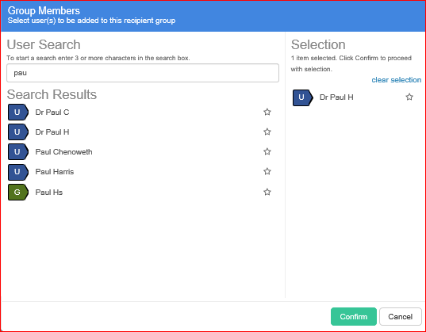
In the search field, at least 3 characters is needed to search for a user. Choose the appropriate user on the left, and they will appear in the Selection list on the right. Repeat until you have all the users required for this group.
If you make a mistake and include a user on the right that you do not want in this group, click on their name & they will be removed. Once all users for this group have been added, click Confirm.

6. The group will then display all Group Members. Click Back to List to see existing Groups.

To edit an existing User Group:

1. Access the User Group list as above.
2. Find the relevant group description to edit and choose the Action on the right hand side.
3. Choose Edit
4. Make the relevant changes and click Update.
Top Tip: Choose Manage Members to add, edit or remove individual users. Choose Clear Members to remove all users.

To make a group inactive:

1. Access the User Groups list as above.
2. Find the relevant user to make inactive, and chose the Action on the right hand side.
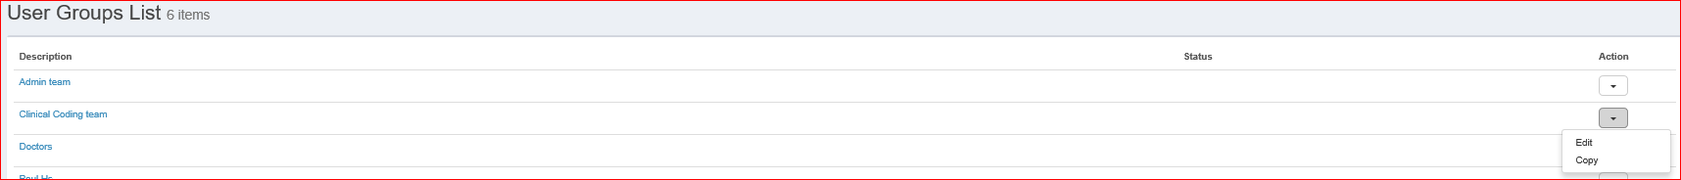

3. Choose Edit.
4. Tick the Inactive Status box and Update
5. This will then show that the user group has an Inactive Status, and the Group will no longer be available to find.

© The copyright in this document is owned by PCTI Solutions Limited, including (without limitation) in all alpha-numeric text and code, images, schematics and illustrations. No part of this document may be reproduced, stored in a retrieval system, or transmitted in any form or by any means without the express written consent of PCTI Solutions Limited. The information in this document is provided for information only and is subject to change without notice. While we make strenuous efforts to ensure that the content of this document is accurate and up to date when published, PCTI Solutions Limited gives no warranty on its accuracy and assumes no responsibility or liability for any errors or inaccuracies whatsoever (to the extent such exclusion is permitted by applicable law).

