‘HOW TO’ GUIDE

User List maintenance

Role requirements to access the User List:
Docman roles: Docman System Administrator
Docman Supervisor

RBAC Roles: Systems Support Access Role

1. To access the Users folder, click on Settings on the ribbon. The Users folder is then listed on the left hand side.

2. Choose the Users folder, and the Users subfolder beneath it.
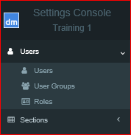

To create a new user:

3. Within the Users subfolder, choose Create New User in the bottom left corner.
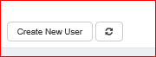

4. Complete screen 1 of 2 as below and click Next.
NB: Items marked with an asterix * are mandatory fields.
Top tip: The Full Name will appear in the user list, within this section, and when choosing users in a pick list (i.e. to send a task to etc). The User Name is what the user will need to log in to Docman (assuming Single Sign On is not switched on).
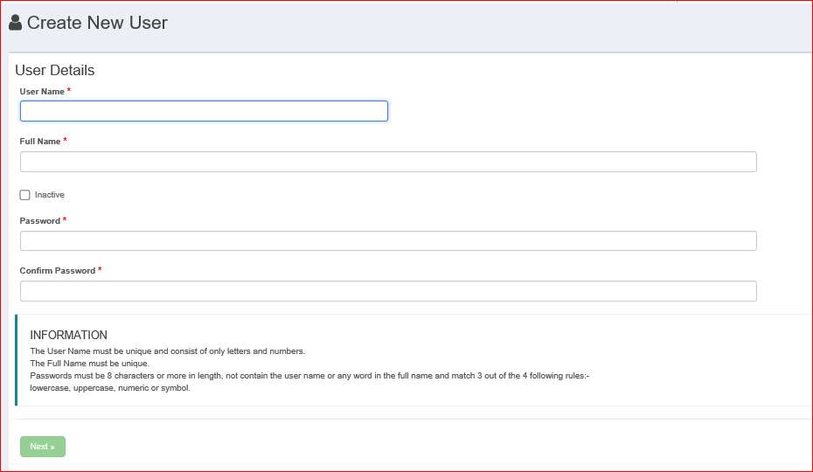

5. On the 2nd page, you can set a Windows password, a preferred name and gender, if required. You can also change a users password on their behalf, and add an email address to allow the user to reset their own password, if needed.
Each user will need at least one user role:
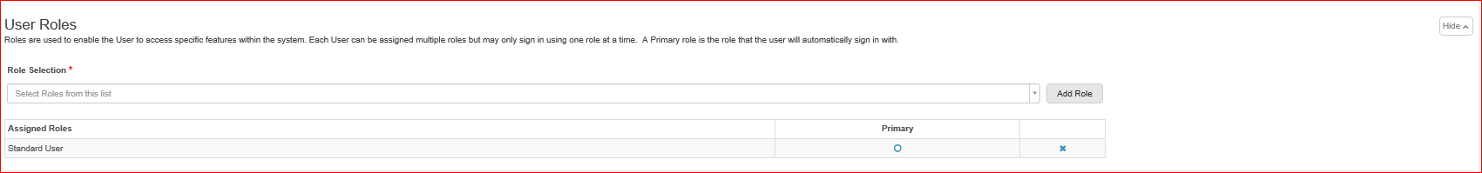
Choose the appropriate role from the dropdown picklist, and click Add Role.
The role will then appear in Assigned Roles. Tick Primary if this is the only role for this user.
If the user will have more than one role, repeat to add more roles, choosing the role that will be their default role. NB: Only one role can be a Primary role (i.e. a default role)
NB: If you do not add at least one role the following message will appear:
WARNING: No Roles have been assigned to the user, and the user will not be able to login until at least one Role is assigned and one designated as the Primary Role.
Contact details, Professional codes & Contractual relationship details can be added, if required.
6. Click Update to complete.

To edit an existing user:

1. Access the Users list as above.
2. Find the relevant user to edit and choose the Action on the right hand side.
3. Choose Edit
4. Make the relevant changes and click Update.
Top Tip: If a user locks their account, you can edit the user, and untick the locked status.
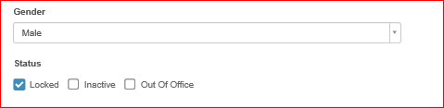

To make a user inactive:

1. Access the Users list as above.
2. Find the relevant user to make inactive, and chose the Action on the right hand side.
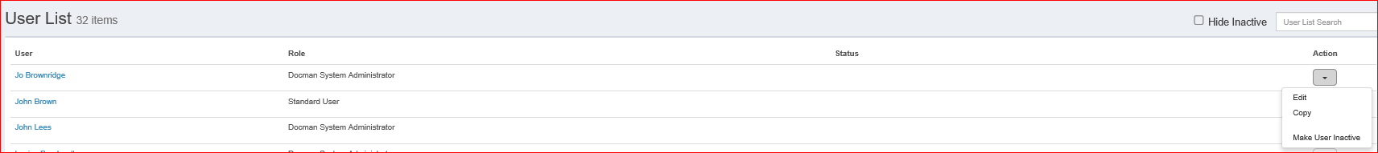

3. Choose Make User Inactive
4. Complete the reason for making the user inactive (i.e. Left the practice) and click OK
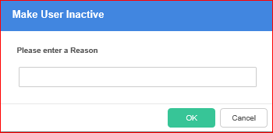
Alternatively, edit the user and tick the Inactive Status (remember to click Update at the bottom of the screen)
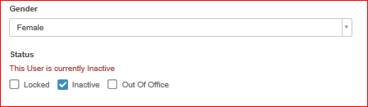

5. This will then show that the user has an Inactive Status.

6. You can hide Inactive users from view by ticking the Hide Inactive box in the top right hand corner.

NB: It is your responsibility to maintain your user list, and you should make users inactive as soon as you are aware they are no longer a member of staff at the practice.

Top Tip: If a user has outstanding active tasks, you must ensure that the task is dealt with, before you make the user inactive. If you attempt to make a user inactive, the following message will appear. Ensure you have created a task view, before you continue.
.
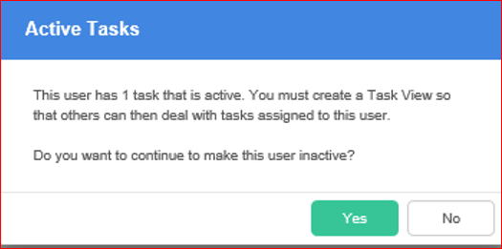

© The copyright in this document is owned by PCTI Solutions Limited, including (without limitation) in all alpha-numeric text and code, images, schematics and illustrations. No part of this document may be reproduced, stored in a retrieval system, or transmitted in any form or by any means without the express written consent of PCTI Solutions Limited. The information in this document is provided for information only and is subject to change without notice. While we make strenuous efforts to ensure that the content of this document is accurate and up to date when published, PCTI Solutions Limited gives no warranty on its accuracy and assumes no responsibility or liability for any errors or inaccuracies whatsoever (to the extent such exclusion is permitted by applicable law).

